## YOGA AWARENESS & PRACTICE

### (Community Service Project Report)

#### Submitted in accordance with the requirement

#### for

***the degree of***

### BACHELOR OF TECHNOLOGY

**IN**

**DATA SCIENCE**

***Under the esteemed guidance of***

### Mr.T.V.D.PRASAD

**Asst Professor**



**DEPARTMENT OF COMPUTER SCIENCE AND ENGINEERING**

# GUNTUR ENGINEERING COLLEGE

**(Approved by AICTE New Delhi & AfCiliated to JNTUK, Kakinada)**

##### YANAMADALA (V), PRATHIPADU (M), GUNTUR (Dt) A.P. – 522019

**Website: www.gecg. in**

# GUNTUR ENGINEERING COLLEGE

(Approved by AICTE New Delhi & Affiliated to JNTUK, Kakinada)

YANAMADALA (V), PRATHIPADU (M), GUNTUR (Dt) A.P. – 522019

Website: gecg.in

PROGRAM BOOK FOR

COMMUNITY SERVICE PROJECT REPORT ON YOGA AWARENESS AND PRACTICE

II B.TECH CSE (DS) 1st SEMESTER

ACADEMIC YEAR: 2022-2023

**SUBMITTED BY:**

**TEAM LEADER:** G.Narendra Reddy (22JK1A4425)

**TEAM MEMBERS:**

**1**.CH. Narendra **(22JK1A4420)**

**2**.I.Nageswararao **(22JK1A4427)**

1. SK. Abdul Shoaib **(22JK1A4440)**
2. SK.M.Subhani Arif (**22JK1A4441)**

**GUNTUR ENGINEERING COLLEGE**

YANAMADALA

**DEPARTMENT OF COMPUTER SCIENCE AND ENGINEERING**



# CERTIFICATE

We are the student’s of B-TECH, CSE-DS JNTUK ,do here by declare that the project report entitled “YOGA PRACTICE AND AWARENESS” is the genuine work carried out at GUNTUR ENGINEERING COLLEGE under the Guidance of Mr.T.V.D.PRASAD, assistant professor, Department Of Computer Science and Engineering ,GUNTUR ENGINEERING COLLEGE , We declare that the work embedded in the thesis has not been submitted for the award of credits for Degree

**Mr.T.V.D.PRASAD Dr .R .BULLIBABU , M.Tech.Ph.D**

##### Assistant Professor HOD - CSE DEPARTMENT FACULTY GUIDE

**INTERNAL EXAMINER**

# Community Service Project Report

Submitted in accordance with the requirement for the degree of.....

**Name of the college** : Guntur Engineering College

**Department** : Computer Science & Engineering  
**Name of the faculty guide** : Mr.T.V.D.PRASAD

**Duration of the CSP project** :

**Name of the student** :

G.Narendra Reddy

CH. Narendra

I.Nageswararao

SK. Abdul Shoaib

SK.M.Subhani Arif

### Programm of study :Yoga Awareness And Practice

**Year of study** 2

### Register no’s :

**Date of submission** :

# Student’s Declaration

We are the student’s of B-TECH, CSE-DS, JNTUK ,do here by declare that the project Report Entitled “YOGA PRACTICE AND AWARENESS” is the genuine work carried out at GUNTUR ENGINEERING COLLEGE under the Guidance of Mr.**T.V.D.PRASAD** , assistant professor, Department Of Computer Science and Engineering ,GUNTUR ENGINEERING COLLEGE , We declare that the work Embedded in the thesis has not been submitted for the award of credits for degree .

1. G.Narendra Reddy **(22JK1A4425)**
2. CH. Narendra **(22JK1A4420)**
3. I.Nageswararao **(22JK1A4427)**
4. SK. Abdul Shoaib **(22JK1A4440)**
5. SK.M.Subhani Arif (**22JK1A4441)**

# 

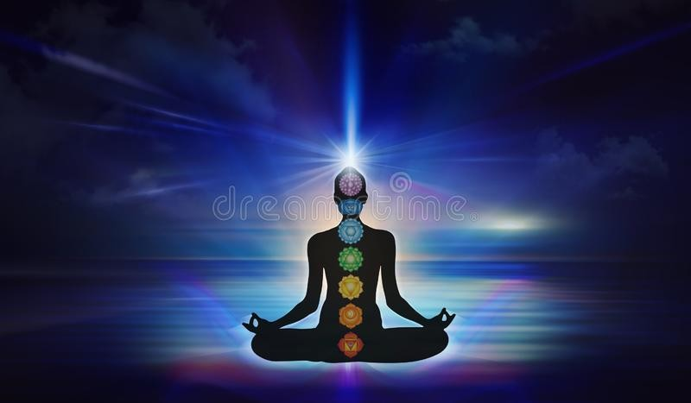

ACKNOWLEDGEMENT

We write this acknowledgement with the great honour, pride and pleasure to pay respects to all who enabled us directlyor indirectly in reaching this stage.

We express our sincere thanks to our beloved chairman **Sri Koyi Subba Rao**, secretary **Sri Koyi Sekhar**, for providing support andstimulated environment for completing the project.

We would especially like to thank **Dr. Kalluri Rama kotaiah, Principal** for providing us the resources for carrying out the project.

We are grateful to **Dr.R.BulliBabu**,Professor &Head of the Department of Computer Science &Engineering for his inspiration and above all the moral support and the constant encouragement in carrying out this project work.

I express my deep gratitude to **Mr.T.V.D.PRASAD** mentor of my project for his valuble encourage suggestion and guidelines in every stage of the completion of the project successfully.

We are greatfull to all the faculty of CSE Dept. of Guntur Engineering College.Our classmates and friends for their valuable suggestion and cooperation I completing the project report.

## CONTENTS

|  |  |  |
| --- | --- | --- |
| **S.NO** | **TOPICS** | **PAGE NO** |
| CHAPTER 1 | Executive Summary |  |
| CHAPTER 2 | **Over View of the Community**   1. About Community 2. Socio Economic Conditions of the Community |  |
| CHAPTER 3 | **Community Service Part** Activity Log Book – First Week & WeeklyReport  Activity Log Book – Second Week & WeeklyReport |  |
| CHAPTER 4 | **Main Project Work**  1. Introduction about Topic2.Methodology   1. Data Analysis 2. Activity Log Book – Third - Sixth Week &Report |  |
| CHAPTER 5 | **Outcomes Description**  1. Questionnaire with Photo 2.Problems Identified in the community  3.Short Term and Long Term Action Plan4.Community Awareness Program |  |
| CHAPTER 6 | **Recommendations and Conclusions**   1. Student Self Evaluation 2. Evaluation by the Supervisor |  |
| CHAPTER 7 | **Bibliography -** ReferencesPhotos Video Links |  |
| CHAPTER 8 | **Evaluation**   1. Marks Statement 2. Internal Assessment Statement |  |

### CHAPTER 1: EXECUTIVE SUMMARY

*With survey to know the yoga is h*uman beings are made up mainly three elements which are the mind, body, and soul. Similarly, in order to satisfy the needs of these three, we need knowledge, health and inner peace respectively.

As we know, health is a physical need whereas knowledge is the psychological need of ours. When we talk about inner peace, we see it refers to the spiritual need and we feel harmonious only when all three are present.

Yoga is something that feeds our soul. It is a spiritual practice which relieves us of many ailments physically.

Moreover, exercise can strengthen our bodies and also sharpen our intellect and steady our emotions.

BR-stadium is located in Guntur we taken the awareness from that stadium it was useful for the communicate with more people by taking the challenge of yoga ,and it’s types.

##### Activities:

* 1. Conducting a survey in the Guntur BR-stadium
  2. Identifying the problems in the Guntur BR-stadium
  3. Solutions.
  4. Awareness Program.
  5. Recommendations.

### CHAPTER 2: OVERVIEW OF THE COMMUNITY

**Guntur :**

Guntur is a city in Guntur district of the Indian state of Andhra Pradesh. It is a municipality and the headquarters of guntur and Guntur revenue division. The city is renowned for art, culture, drama and hence, it is . It is one of the twelve urban local bodies in Andhra Pradesh Capital Region and the twelfth most populous city in the state, with a population of 199,345 as of 2011. Guntur City is also part of Andhra Pradesh Capital Region Development Authority (APCRDA). Guntur, is a town and a Mandal in Guntur District of Andhra Pradesh, South India. It has a population of 149,839 (2001 census). It is located 16 miles east of Guntur City. Three canals of the Krishna River flow through Guntur making it a part of the rice bowl of Andhra Pradesh. One of the canals is navigable up to Nizampatnam port. Guntur is a major railway junction connecting Guntur, Vijayawada, Repalle and Chennai. It is also popularly known as Andhra Paris. Guntur is known for its rich historical, agricultural, cultural and literary legacy. It is the Second largest town after Guntur in Guntur District. It has produced many famous poets, theatre artistes, scholars, actors, scientists and academicians. It is well known for the Vaikuntapuram temple which gets visited by an average of 35,000 devotees every month to get a glimpse of the Lord Venkateswara.

### HISTORY OF GUNTUR:

‘Andhra Paris’ Guntur is one of the sacred places of Panchayati in the delta area of Krishna River. The Archaeological monuments revealed that the village ‘Teravali’ gradually became Guntur and it is also reputed for devotees, intellectuals, orators, artists and educationalists from ancient days.

During the British imperial rule, Guntur was in Repalle Taluk in Machilipatnam district, which was later divided into Krishna, and Godavari districts. In 1904 Krishna District was again separated into Krishna and Guntur Districts. Repalle Taluk was divided into Repalle and Guntur Taluks in 1909.Construction of canals and dams in Guntur Taluk by Captain Alexander Orr in 1890 gave a boost to irrigation. Oriental College was established here in 1890, the first High school was started in 1903 and the first Degree College in 1951.

During 1930’s the famous writer “Sri Chilakamarthy Lakshmi NarasimhamPanthulu” referred to Guntur as “Andhra Paris” as this town was rostrum for myriad literature fine arts and artists with a great literary and cultural heritage and excellence.

freedom fighters who sacrificed their life. Andhra Paris here leaded many histrionic associations.It was the domicile of doyen of several social and revolutionary moments viz. Non Brahmin Movement 1920 (Suryadeva raghavaiah Chowdary), Rationalist movement 1940 (Kaviraju Sri Tripuraneni), Radical Humanist Movement 1950 (Sri M.N. Roy) etc., No 10, Downing street in London is the official residence of the British prime Minister and as such as experts great influence on British politics, similarly Guntur also was always the severe center of Andhra Pradesh Politics. Hence many people referred to Guntur as the Downing Street of Andhra, in views of its place, role and importance in Andhra Politics. It is second educational centre in Guntur district by having several Schools, Junior Colleges and Degree Colleges with various Post-Graduate courses. The city is notable for drama, fine arts, literature and poetry. The

iconic Martyr's Memorial at Ranarang Chowk denotes the impact of the city on the Indian freedom struggle during the Quit India Movement. The people of Guntur had responded to Mahatma Gandhi's call and organised a bandh on 12 August 1942.

### DRAMA AND LITERATURE:

The city has been the host for events such as the formation of the 1929 Andhra Nataka Kala Parishad, the Kanyasulkam play, and cultural fests. Guntur Ramakrishna, one of the eight poets in the court of Sri Krishna Devaraya, hails from Guntur. In the area of modern literature are contributors such as Chakrapani, Gudipati Venkata Chalam, KodavatigantiKutumbarao, Tripuraneni Ramaswamy. Furthermore, Nethi Parameswara Sarma wrote the book Nurella Guntur RangastalaCharitra, which translates to 100 years of theater in Guntur.

### FILMS:

Many artists who hail from Guntur and the nearby villages have contributed a major share to the Telugu film industry, such as AVS, GovindarajulaSubba Rao (the first Telugu cinema hero), Krishna, GummadiVenkateswara Rao, Jamuna, Kanchanamala (the first Telugu cinema heroine), KongaraJaggayya, Rama Prabha, Savitri, Sharada, Siva Parvati and Divya Vani,Wahidarahman, Krishna, Maheshbabu.

### AGRICULTURE:

Guntur thrives on trade and agriculture. Irrigation in the Western Delta, the region in which the city lies, is supported by water from the Krishna river.Among major crops the main crop cultivated in Guntur is paddy. As the land is very fertile in this area and also many other crops like Maize,Banana,Turmeric,Wheat,Green chilies ETC.

### POPULATION:

Guntur city is governed by Municipal Corporation and is situated in Andhra Pradesh State/UT. As per provisional reports of Census India, population of Guntur in 2011 is 164,937; of which male and female are 81,427 and 83,510 respectively.

### EDUCATION:

The primary and secondary school education is imparted by government, aided, and private schools, under the School Education Department of the state. As per the school information report for the academic year 2015–16, there are a total of 71 schools, comprising 26 private schools, 44 municipal schools, and 1 other type of school. Adarsh Public School, Sharon Talent School St. John's Public School, Kendriya Vidyalaya, and Westberry School are some of the public and private schools under CBSE and state boards. Yalavarthy Veda Pathashala, one of the oldest vedic schools founded in 1894, is located in Gandhi Nagar area of the city. There are 20 private aided junior colleges, such as the Taluk Junior college, the JMJ college for Women, the VSR and NVR college, and the Dr. B. R. Ambedkar Memorial Junior college. Additionally, fourteen unaided junior colleges provide undergraduate education.The JMJ college for women and the VSR and NVR college are the two autonomous colleges under Acharya Nagarjuna University. There are colleges for different fields of study, such as nursing, Government Industrial Training Institute, and other institutes for vocational courses

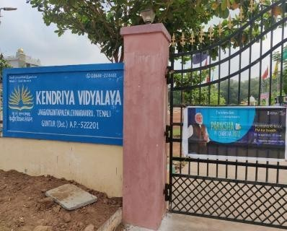

1. Managing time
2. Ability to make decisions
3. The importance of environmental preservation.

### CHAPTER 3: COMMUNITY SERVICE PART

Description of the Activities undertaken in the Community during the Community Service Project. This part could end by reflecting on what kind of values, life skills, and technical skills the student acquired

## Life Skills:

**Technical Skills:**

* + 1. Power of Presence
    2. The Ability to Be Empathetic
    3. Leadership
    4. Physical Fitness
    5. Active Listening Skills
    6. The value of yoga
    7. Improve mind power
    8. Improve the physical
    9. Healthy taking food
    10. Punctuality

##### ACTIVITY LOG FOR THE FIRST WEEK

|  |  |  |  |
| --- | --- | --- | --- |
| **Da y & Da te** | **Brief description of the daily activity** | **Learning Outcome** | **Person In- Charge Signatur e** |
| Day – 1 | Study about the evaluation of yoga | What is yoga? |  |
| Day - 2 | Searching for yoga trainer | I found a good trainer Mr.venkatesh |  |
| Day – 3 | Searching for yoga trainer | He was a well in yoga asanasand taking care when I did |  |
| Day – 4 | Study of yoga asanas with trainer | How many types of yogaasanas? |  |
| Day – 5 | Study of yoga asanas with trainer | What is the use of yoga? |  |
| Day – 6 | Study of yoga asanas with trainer | What are the benefits of yogaasanas? |  |

**WEEKLY REPORT**

**WEEK – 1 (From Dt………..….. to Dt )**

Objective of the Activity Done:A brief research done on the history of yoga asanas and Trainer&yoga types.

Detailed Report:I had completed the detailed research on the evaluation of yoga &it’s types. Yoga is an Art and Science of healthy living. It is a spiritual discipline based on an extremely subtle science, which focuses on bringing harmony between mind and body. The holistic approach of Yoga brings harmony to all walks of life. Yoga is also known for disease prevention, promotion of health and management of many lifestyle related disorders. The word yoga literally means “to yoke” or “union”. More than just a practice of physical exercises, Yoga is the coming together of the individual self or consciousness, with the infinite universal consciousness or spirit. Yoga is a method of inquiry into the nature of the mind, which emphasizes practice and direct experience. It includes various practices and techniques mentioned in the yogic literature and are collectively referred to as ‘Yoga’. Yoga encourages a positive and healthy lifestyle for the physical, mental and emotional health of children. Yoga helps in the development of strength, stamina, endurance and high energy at physical level. It also empowers oneself with increased concentration, calm, peace and contentment at amental level leading to inner and outer harmony. Yoga brings stability to the body and the wavering mind. It increases the lubrication of joints,ligaments, and tendons of the body. It reduces the risk of many diseases. Yoga can create a permanently positive difference to the lifestyle of anybody practising it on a regular basis. Yoga is a perfect way to ensure overall health and physical fitness. The physical building blocks of yoga are the posture (asana) and the breath. Through meditation, breathing exercises (called pranayama), you can banish all your stress and lead a healthy life. A series of poses held in time with breathing, exercises every part of the body. Yoga increases strength, endurance, flexibility, and balance.

##### ACTIVITY LOG FOR THE SECOND WEEK

|  |  |  |  |
| --- | --- | --- | --- |
| **Da y & Da te** | **Brief description of the**  **dailyactivity** | **Learning Outcome** | **Person In- Charge Signatur e** |
| Day – 1 | Learning &praticing of yoga asanas  ( Dhanurasana,Bhujngasana, Sirsasana) | Dhanurasana, Bow pose, Bhujangasana or Cobra Pose, is a reclining back- bending asana Salamba Shirshasana, often shortened to Shirshasana, or Yoga |  |
| Day - 2 | Learning &praticing of yoga asanas (Padmasana,UtthitaParsvakonasana  ,Natrajasana) | Lotus  position or Padmasana is a Utthitaparsvakonasana, Extended Side Angle Pose, Natarajasana, Lord of the Dance Pose or Dancer Pose isa standing, |  |
| Day – 3 | Learning &praticing of yoga asanas (Halasana,Vajrasana,Virabhabrasana) | Halasana or Plough pose, isan inverted asana in hatha yoga  Vajrasana, Thunderbolt Pose, or Diamond Pose, Virabhadrasana or WarriorPose is a group of |  |
| Day – 4 | Learning &praticing of yoga asanas (SuryaNamaskar,Charakrasana,Ustra sana) | Surya Namaskar, Salute tothe Sun or Sun Salutation, Chakrasana, Wheel  Pose or Urdhva Ustrasana, Ushtrasana, or Camel Pose is a kneeling back-bending asana |  |
| Day – 5 | Learning &praticing of yoga asanas (Sarvangasana,Bhairavasana,Siddhas ana) | Sarvangasana, Shoulderstand, Bhairavasana or formidable pose,  Siddhasana or AccomplishedPose, |  |
| Day – 6 | Learning &praticing of yoga asanas (Tadasana,Navasana,SetuBandhaSar vangasana) | Tadasana, Mountain PoseNaukasana, Boat Pose,  or Paripurna Navasana Setu Bandha Sarvangasana,  Shoulder supported bridge orsimply Bridge, |  |

**WEEKLY REPORT**

**WEEK – 2 (From Dt………..….. to Dt )**

|  |
| --- |
| **Objective of the Activity Done:** |
| **Detailed Report:**The name comes from the Sanskrit words धनुर (dhanura) meaning "bow", and  आसन (āsana) meaning "posture" or "seat".  A similar pose named Nyubjasana, "the face-down asana", is described and illustrated in the 19th century Sritattvanidhi.The pose is illustrated in half-time in the  1905 Yogasopana Purvacatuska and named Dhanurāsana, quoting the *Gheranda Samhita'*s |
| Lotus position or Padmasana is a cross-legged sitting meditation pose from ancient India, inwhich each foot is placed on the opposite thigh. |
|  |
| The pose may be entered from a prone position or from Downward Dog. The palms are placedunder the shoulders, pushing down until the hips lift slightly. |
| in the Supported headstand (Salamba Shirshasana), the body is completely inverted, and heldupright supported by the forearms and the crown of the head. |
| Utthita Parsvakonasana, Extended Side Angle Pose, is an asana in modern yoga as exercise. |
|  |
| Natarajasana, Lord of the Dance Pose or Dancer Pose is a standing, balancing, back-bending asana in modern yoga as exercise |
| Halasana or Plough pose, is an inverted asana in hatha yoga and modern yoga as exercise. Itsvariations include Karnapidasana with the knees by the ears, and Supta Konasana with the feet wide apart. |
| The practitioner sits on the heels with the calves beneath the thighs. There is a four finger gapbetween the kneecaps, and the first toe of both the feet touch each other and sit erect. |
| The name of the pose derives from the Hindu myth, but the pose is not recorded in the hathayoga tradition until the 20th century. |
| The asana sequence was first recorded as yoga in the early 20th century, though similar exercises were in use in India before that, for example among wrestlers. |
| similar poses were used in medieval hatha yoga. Many named variations exist, including withlegs in lotus position and Supta Konasana with legs wide apart, toes on the ground. |
| The names Muktasana and Burmese position are sometimes given to the same pose, sometimesto an easier variant. |

##### ACTIVITY LOG FOR THE THIRD WEEK

|  |  |  |  |
| --- | --- | --- | --- |
| **Da y & Da te** | **Brief description of the daily**  **activity** | **Learning Outcome** | **Person In- Charge Signatur e** |
| Day – 1 | Learning &praticing of yoga asanas (Paschimottanasana,Shavasana,Vriksas ana) | Paschimottanasana, SeatedForward Bend, Shavasana, Corpse Pose,or Mrtasana, Vrikshasana or Tree Poseis a balancing asana. |  |
| Day - 2 | Learning &praticing of yoga asanas(Trikonasana,Baddha Konasana) | Trikonasana or UtthitaTrikonasana, Baddha Konasana, BoundAngle Pose, |  |
| Day – 3 | Learning &praticing of yoga asanas (Gomukhasana,ViparithaDandasana,Ba kasana) | Gomukhasana or CowFace Pose Viparita Dandasana or Inverted Staff Pose Bakasanasimilar Kakasana(Crow pose) |  |
| Day – 4 | Learning &praticing of yoga asanas (Utkatasana,AshtangaNamaskara,Uttan asana) | Utkatasana, Chair Pose, Ashtanga Namaskara alsocalled Ashtanga DandavatPranam, Uttanasana or StandingForward  Bend |  |
| Day – 5 | Learning &praticing of yoga asanas (Salabhasana,UpavistaKonasana,Utthi tapadangusthasana) | Shalabhasana is one of themost well-known poses of Yoga.  *Upavistha konasana* is aseated forward bend padangusthasana widelyhand-to-big-toe pose. |  |

|  |  |  |  |
| --- | --- | --- | --- |
| Day – 6 | Learning &praticing of yoga asanas(Garbha Pendasana, Anjaneyasana,Dandasana) | Garbha Pindasana, Embryoin Womb Pose, Anjaneya is the Sanskrit word which means “Son ofAnjani”  Dandasana (Staff Pose) isa foundational seated pose |  |

**WEEKLY REPORT**

**WEEK – 3 (From Dt………..….. to Dt )**

|  |
| --- |
| **Objective of the Activity Done:** |
| **Detailed Report:**Paschimottanasana, Seated Forward Bend, or Intense Dorsal Stretch is aseated forward-bending asana in hatha yoga and modern yoga as exercise. The pose is entered from Dandasana (the seated Staff Pose) by bending forward from the hips withoutstraining and grasping the feet or lower legs. |
| It is the usual pose for the practice of yoga nidra meditation. The name comes from theSanskrit words शव Śava, “corpse” and आसन Āsana, “posture” or “seat”. |
| Vrikshasana or Tree Pose is a balancing asana. It is one of the very few standing hatha yoga, The name comes from the Sanskrit words vṛkṣa (वृक) meaning “tree”, and āsana (आसन) meaning “posture”. |
| Trikonasana or Utthita Trikonasana, Triangle Pose is a standing asana in modern yoga asexercise. Variations include Baddha Trikonasana (bound triangle pose) and Parivrtta Trikonasana (revolved triangle pose). |
| Baddha Konasana, Bound Angle Pose, Throne Pose, Butterfly Pose, or Cobbler’s Pose (after the typical sitting position of Indian cobblers when they work), and historicallycalled Bhadrasana, is a seated asana in hatha yoga and modern yoga as exercise. |
| Gomukhasana or Cow Face Pose is a seated asana in hatha yoga and modern yoga asexercise, sometimes used for meditation. |
| Viparita Dandasana or Inverted Staff Pose is an inverted back-bending asana in modern yoga as exercise. It may be performed with both feet on the ground, or with one leg raisedstraight up |
| Bakasana (Crane pose), and the similar Kakasana (Crow pose) arebalancing asanas in hatha yoga and modern yoga as exercise. |
| Utkatasana, Chair Pose, is a standing asana in modern yoga as exercise. It was a lowsquatting asana in medieval hatha yoga. |
| Ashtanga Namaskara also called Ashtanga Dandavat Pranam, Eight Limbed pose, Caterpillar pose, or Chest, Knees and Chin pose is a posture sometimes used in the Surya Namaskar sequence in modern yoga as exercise, |
| The name comes from the Sanskrit words उत्न uttāna, “intense stretch”; and आसन;  āsana, “posture” or “seat”. |

##### ACTIVITY LOG FOR THE FORTH WEEK

|  |  |  |  |
| --- | --- | --- | --- |
| Da y & Da te | Brief description of the daily  activity | Learning Outcome | Person In- Charge Signatur e |
| Day – 1 | Learning &praticing of yoga asanas (GarbhaPindasana,Svastikasana,Bidala sana) | Garbha Pindasana, Embryoin Womb Pose, Svastikasana is an ancient meditation in hatha Bidalasana or Marjariasana both meaning Cat Pose in Sanskrit, |  |
| Day - 2 | Learning &praticing of yoga asanas (Travikaramasana,AdhoMukhaShvanas ana) | Trivikramasana or the standing splits is a standingasana in hatha yoga.  Adho Mukha Shvanasanais an inversion |  |
| Day – 3 | Learning &praticing of yoga asanas (Makarasana,Anantasana,Malasana,Jan usirsasana) | Krauncasana or Heronpose, Makarasana or  Crocodile pose reclining asana in hatha yoga |  |
| Day – 4 | Learning &praticing of yoga asanas (Parighasana,pasasana,ViparitaKarani, Tittibhasana) | Parighasana or Gate Pose Pasasana or Noose Pose isan asana. i Tittibhasana or Firefly pose is an arm-balancing asana |  |
| Day – 5 | Learning &praticing of yoga asanas (Bhujapidasana,Marichyasana,SuptaPa dangusthanasana) | Bhujapidasana or Shoulderpressing  Supta Padangusthasana, Reclining Hand to Big Toepose, Marichyasana, the pose of the sage Marichi is a sittingtwist asana |  |
| Day – 6 | Learning &praticing of yoga asanas (Balasana,Durvasana,matsyendrasan a) | Balasana, Child’s  Pose, or Child’s Resting Durvasasana Matsyendrasana, Matsyendra’s Pose |  |

**WEEKLY REPORT**

**WEEK – 4 (From Dt………..….. to Dt )**

|  |
| --- |
| **Objective of the Activity Done:** |
| **Detailed Report:** Trivikramasana or the standing splits is a standing asana in hatha yoga. The name of this pose comes from Trivikrama |
| Svastikasana is an ancient meditation asana in hatha yoga, sitting cross-legged. InSanskrit svastika means auspicious |
| Bidalasana or Marjariasana both meaning Cat Pose in Sanskrit, is a kneeling asana inmodern yoga as exercise. A variant with one leg held out is Vyaghrasana Tiger Pose. |
| Downward Dog Pose, Downward-facing Dog Pose, or Adho Mukha Shvanasana is aninversion Asana in modern yoga as exercise, |
| Krauncasana or Heron pose, also written Krounchasana, is a sitting asana in modern yoga asexercise. |
| Anantasana Sleeping Vishnu Pose or Vishnu’s Couch Pose, Eternal One’s Pose, or Side-Reclining Leg Lift is an asana in modern yoga as exercise. |
| The name Malasana is used for various squatting asanas in hatha yoga and modern yoga asexercise. |
| Mayurasana or Peacock pose is a hand-balancing asana in hatha yoga and modern yoga asexercise with the body held horizontal over the hands. It is one of the oldest non- seated asanas. |
| Tulasana, Balance pose, Dolasana (Swing pose), Tolasana (Scale pose), or Utthita Padmasana (Raised Lotus pose) is a hand-balancing asana in modern yoga as exercise. |
| Hanumanasana or Monkey Pose is a seated asana in modern yoga as exercise. It is the yogaversion of the front splits. |
| Eka Pada Rajakapotasana or [One-legged] King Pigeon Pose is a seated back-bending asanain modern yoga as exercise. |
| A split (commonly referred to as splits or the splits) is a physical position in which the legsare in line with each other and extended in opposite directions. |
| Urdhva Mukha Shvanasana or Upward Facing Dog Pose is a back-bending asana inmodern yoga as exercise. |
| Jathara Parivartanasana, Revolved Abdomen pose, Belly twist, or Spinal twist is a recliningtwist asana in modern yoga as exercise. |
| Kurmasana, Tortoise Pose, or Turtle Pose is a sitting forward bending asana in hathayoga and modern yoga as exercise. |

ACTIVITY LOG FOR THE FIFTH WEEK

|  |  |  |  |
| --- | --- | --- | --- |
| **Da y & Da te** | **Brief description of the daily**  **activity** | **Learning Outcome** | **Person In- Charge Signatur e** |
| Day – 1 | I wented for survey in guntur at BRstadium | About their daily activities Is the yoga in their daily activities are not and takingany fitness activives.  What they did when they werin stress. |  |
| Day - 2 | I interacted with old mens,asking theirhealth and any yoga activites they perfroms | Health issues like pains, heart  disease,breathing ,meditatio n |  |
| Day – 3 | I interacted with old owmens,asking their health and any yoga activites theyperfroms | Health issue  legpains ,obesityTheir is no yoga activities. |  |
| Day – 4 | I interacted with young age peoples,asking their health and any yogaactivites they perfroms | Heavily stress,  Didn’t concentrate on study orany focusing things also No yoga activites. |  |
| Day – 5 | I wented for survey in college of guntur engineering college interacting with staff | Stress ,workpressure,tensio n,Back pains ,neck pains , No yoga activites |  |
| Day – 6 | I wented for survey in college of gunturengineering college interacting with students | Disturb in their studies ,not focusing concentrate things Heavily stress ,less mind power  No yoga activites. |  |

**WEEKLY REPORT**

**WEEK – 5 (From Dt………..….. to Dt )**

|  |
| --- |
| **Objective of the Activity Done:** |
| **Detailed Report:**In the yoga flexibility is an important component of physical health. Yoga offers many styles to choose from, varying in intensity from high to moderate to mild. Eventhe lowest intensity styles have been found to increase flexibility |
| Yoga is the benift’s for the conversation the American Psychological Association recentlyshared that 84% of American adults are feeling the impact of prolonged stress |
| Often, the precursor to illness is chronic inflammation. Heart disease, diabetes, arthritis, Crohn’s disease, and many other conditions are linked to prolonged inflammation |
| While most people associate yoga with stretching and flexibility, some types of yoga classescan also be considered strength-building. |
| There are a number of different anxiety disorders, such as generalized anxiety disorder, socialanxitey, and specific phobias. |
| It just depends on the class level, approach, and teacher. This makes yoga asana a multimodalform of exercise |
| Even chronic stress can sometimes be categorized as an anxiety disorder. |
| Numerous studies suggest that yoga asana may be effective as an alternative treatment for anxiety disorders |
| though several of the researchers request additional replicated studies before conclusivelystating as much |
| It just depends on the class level, approach, and teacher. This makes yoga asana a multimodalform of exercise |
| Increase cardiorespiratory endurance regulary practicing yoga improves cardiorespiratoryendurance:both decreasing heart rate and increasing maximal oxygen uptake |
| Stress can compound fertility issues ,by encouraging relaxation and calm yoga helps to balance outhormonescan likewise help couples deal with the taxing experience of fertility treatments. |
| A short - team yoga program is sufficient in improving balance ability, As well as increasing legstrength and improving leg muscle control. |

##### ACTIVITY LOG FOR THE SIXTH WEEK

|  |  |  |  |
| --- | --- | --- | --- |
| Da y & Da te | Brief description of the daily  activity | Learning Outcome | Person In- Charge Signatur e |
| Day – 1 | I created a google form and recordedthe various answers from students | I will be able to identify different types of feedbacksfrom my classmates |  |
| Day - 2 | I created a google form and recordedthe various answers from Faculty | I will be able to identify different types of feedbacksfrom my Faculty |  |
| Day – 3 | I conducted awareness program inmarket area at Guntur | Imporatance of yoga , What the benefit’s of yoga ,  Reduce health issues |  |
| Day – 4 | I conducted awareness program inBR- stadium area at Guntur | Incraesing maind power ,Stress relife when yoga activites done |  |
| Day – 5 | I conducted awareness program in ourcollege community | Yoga makes you feelgood-simple as that! |  |
| Day – 6 | I conducted awareness program in ourcollege community | yoga soothes your skin Yoga gives you ome ‘me  -time’ |  |

**CHAPTER 5: OUTCOMES DESCRIPTION**

##### Details of the Socio-Economic Survey of the Village/Habitation Attach the questionnaire prepared for the survey.

1. Full name?
2. Date of birth?
3. Gender?
4. Age?
5. What did you do when your in street?
6. What did you feel when your physically bad?
7. What precaution do about your health?
8. How did you control your feelings?
9. When you feel stress?
10. Having any physical disease?
11. Having any mental disease?
12. What you do when your in free time?
13. Are taking any yoga class?
14. What types of yoga classes like offline(or)online?
15. How many times practice your yoga asanas in a day?
16. Are taking any physical activity?
17. Which time the yoga class held?
18. What type of yoga asanas did you take?
19. Did you feel your fat?
20. Having any breathing problem?
21. Did you feel yoga is the best for any problems in your life?
22. Having any free time in your daily life?



##### COMPUTER SCIENCE & ENGINEERING YOGA PRACTICE AND AWARENESS

Full name :

Date of birth :

Gender : M / F

Age :

What did you do when your in stress :

Are taking any yoga class :

Having any physical disease :

How did you control your feelings :

What you do when your in free time :

What types of yoga classes like ofNline(or)online? :

How many times practice your yoga asanas in a day :

Which time the yoga class held :

What type of yoga asanas did you take :

Did you feel your fat :

**Signature Given By Signature Taken By**

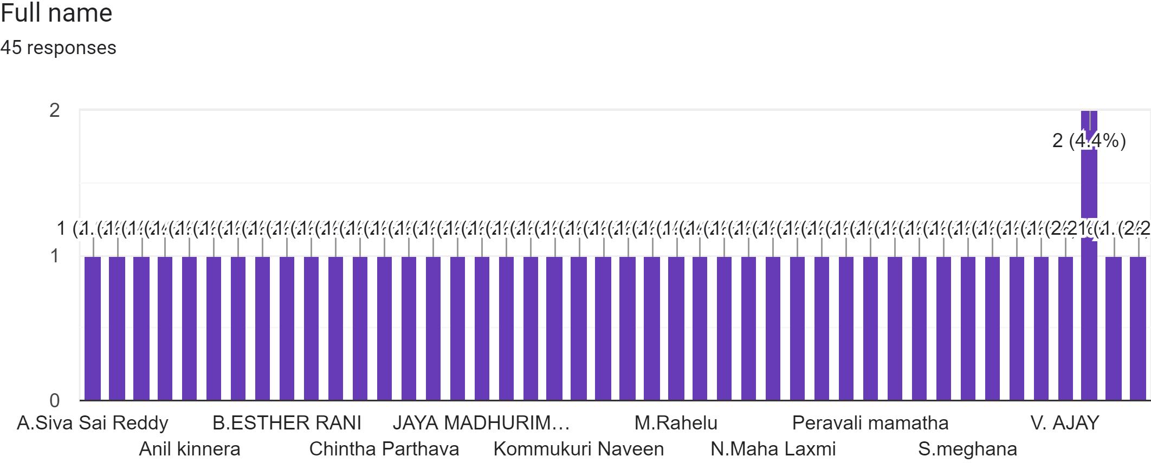

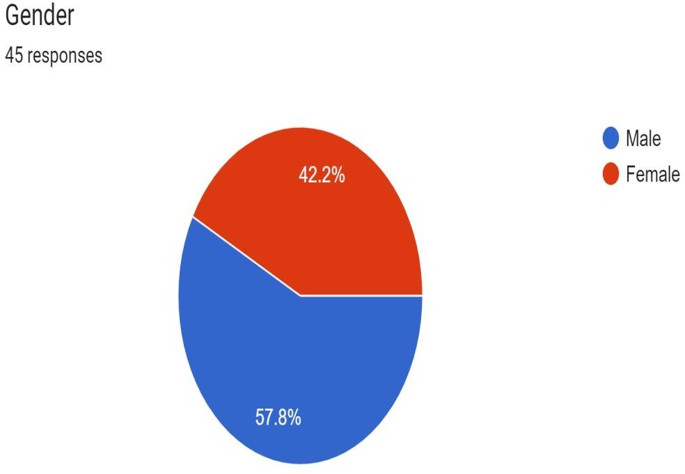

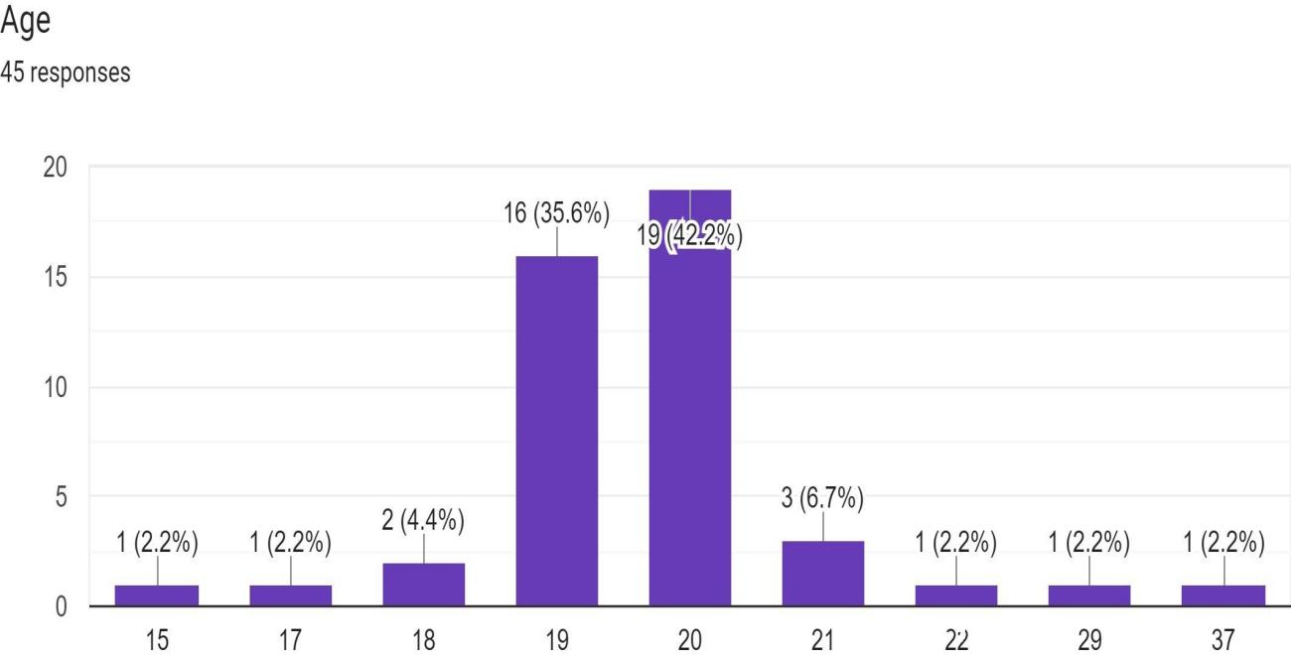

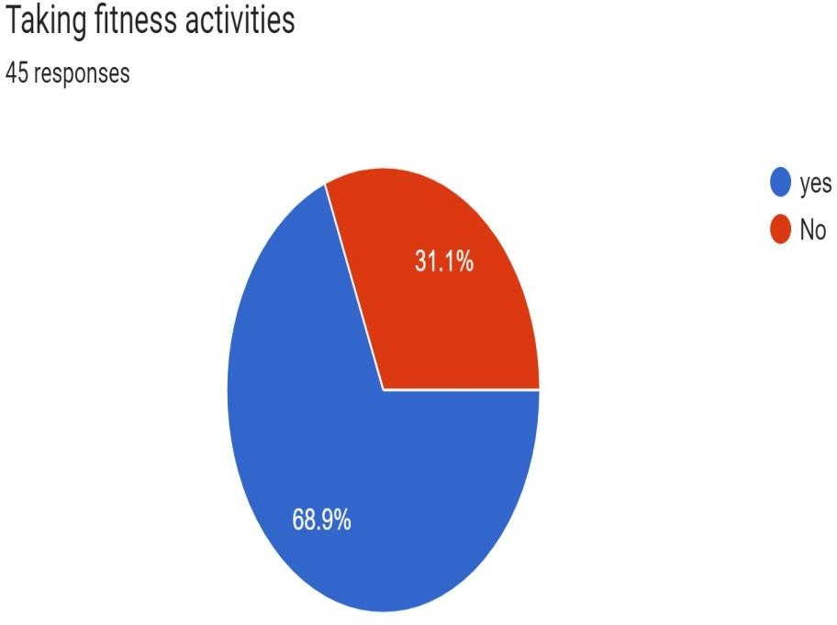

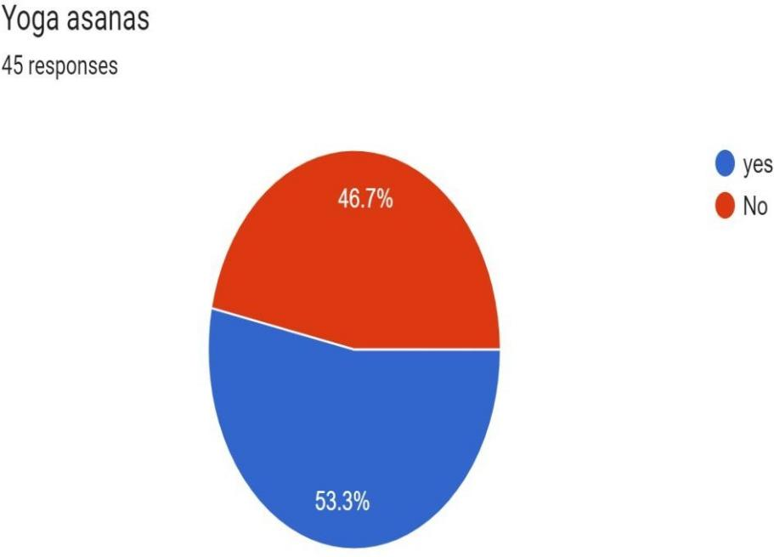

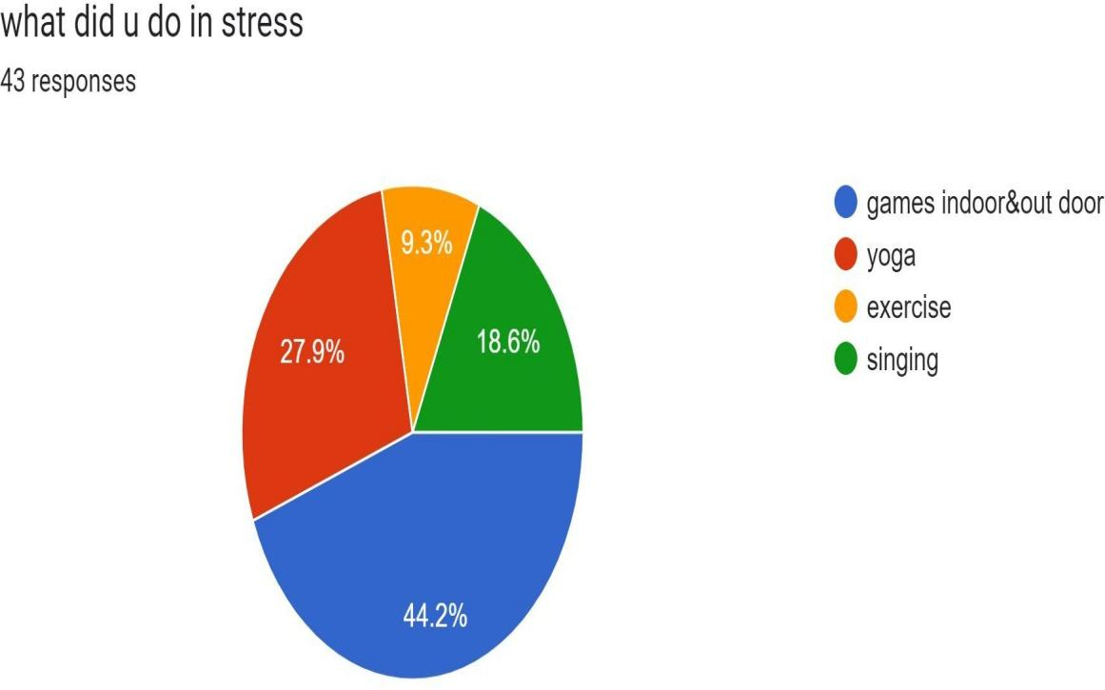

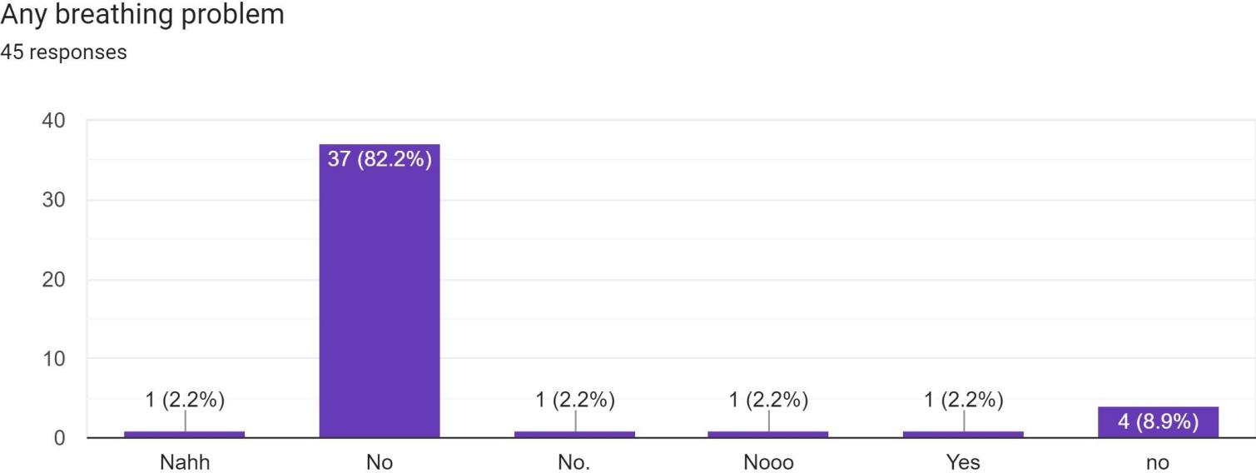

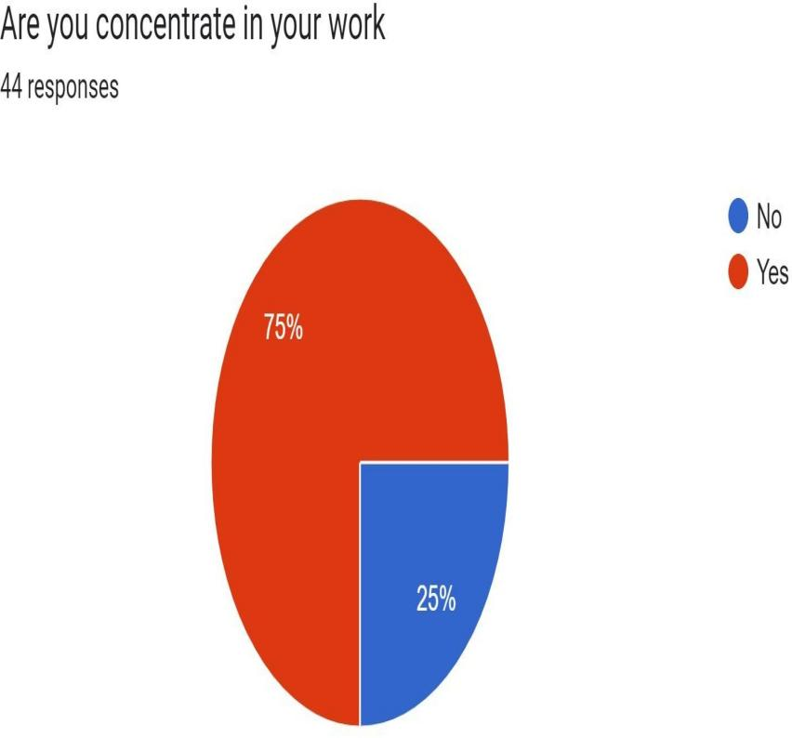

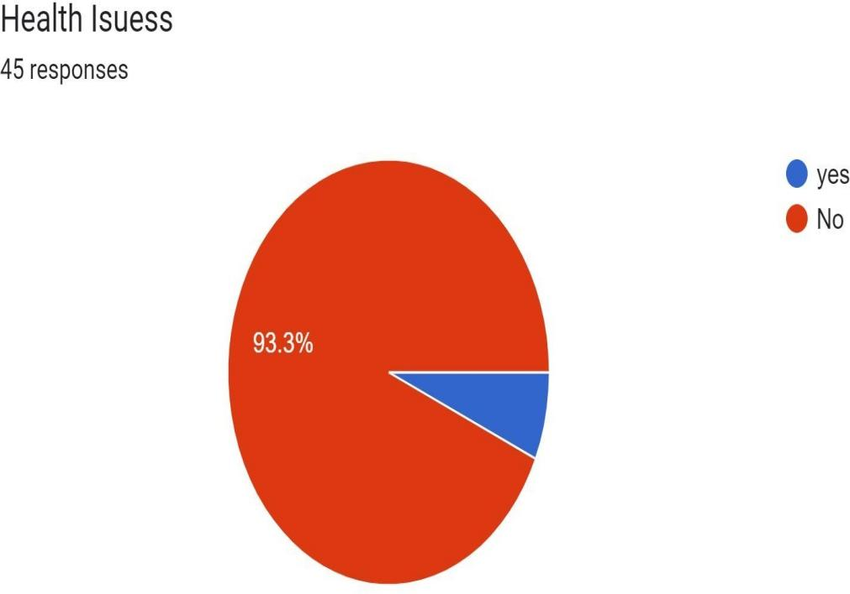

**Short-term:**we heard a lot of problem based on the yoga.we have to clear the sll the doubts based on my knowledge. So we have an awareness based on our project by getting influencein the correct time taking yoga classes daily for half -hour and even more also it could be helpful to improve

Helps improve chronic low-back pain

If you work at a desk (or couch) all day, you may be experiencing some low back, shoulder, and neckpain due to poor posture. “Yoga improves posture, which can prevent low-back pain, as well as shoulder and neck pain,” Dr. Yang says.

Yoga promotes low-back pain relief in two ways: First, the meditation techniques used in yoga encourages relaxation from the physical discomfort related to chronic low-back pain, according tothe National Institutes of health (NIH). Then there are the poses themselves: The physical practicebuilds core strength and stability—something important for posture too—which is one of the mainlines of treatment for addressing low-back pain.

In fact, a 2016 review of 27 studies published in the Journal of Rheumatology and

Orthopedics concluded that yoga appears to be better than the usual standard of care in reducingpeople’s perceptions of the severity of chronic low-back pain, or how bothered they are by theirdiscomfort.

Builds body awareness

When you ground your body to hold all the poses, you recruit a bunch of both big and small muscles. Yoga also focuses on proper form—you need to activate the right muscles—which creates a better understanding of how your muscles, joints, and tissues work together. This can help ensure you movesafely, Courtney says.

Eases you into regular exercise

If you’re new to exercise—or are easing back into a workout routine after a break—vigorous exercise may not seem to be the most appealing.

Helps your heart health

A 2014 review in the European Journal of Preventive Cardiology concluded that yoga has shown some promising benefits for improving cardiovascular disease risk, by lowering heart rate, blood pressure, and even cholesterol. It’s likely due to both the physical aspects of yoga as well as the focus on breath.

##### Long-term:

Based on the problem understandable the yoga practice

Two hours after you eat is generally when you have an empty stomach and it’s okay to practice yoga. If you are starving and want to practice yoga but need some nourishment it’s fine to eat a banana or have a little juice to sustain you through the practice. Just no bean burritos before hitting the mat. After you practice I would wait 30 min for your body to reaclitmate and then eat. This way your body won't go into food shock .

When first starting out try going twice a week then after one month start going three times per week.If you add up to going 5-6 days a week make sure you always have at least one day off so your body can recoperate. Also if you are practicing yoga almost everyday its good idea to mix up the style .

No you don’t have to be flexible to do yoga… It’s an urban myth that people who are tight can't do yoga. Yoga isn’t just stretching its extremely toning, calming, meditative, spiritual, healing and opening. Flexibility is only one aspect of it. Once you practice yoga for a period of time naturally you will gain flexibility with a myriad of other benefits.Practicing in a heated room is the number onecomponent to avoid in a yoga class, as getting over-heated can fry the baby's neurons. Lying on the back can shut off blood to the baby and lying on the stomach can compress the baby.

Inversions are not a great idea as your weight is different when pregnant then when you weren't, soyour center of balance is easily thrown off. I have seen pregnant women fall and its not fun for the mother or the baby.

Yoga asanas are about creating a harmonious integration of breath and movement, so if you applyyogic breathing with cardio, weightlifting it can be considered a form of yoga. So I would mix it up ifit feels appropriate.

“HA” means sun and “THA” means moon. Branches of the yoga practice that involve physical exercise, breathing practices, and movement. These exercises are designed to have a salutary effect on posture, flexibility, and strength and are intended ultimately to prepare the body to remain still for long periods of meditation.

Patanjali's eight-limbed path, also called Raja Yoga. This yoga contains or should contain eight components: morality; ethics; posture; breath control; sense control; concentration; meditation; absorption. Also the "brand" name for the style of yoga developed and taught by Sri K. PattabhiJois with a set sequence of yoga postures that take a student from A-Z in Asana.

Iyengar Yoga, created by B. K. S. Iyengar, is a form of yoga known for its use of props, such as belts and blocks, as aids in performing asanas (postures)… This style of yoga is extremely alignment based and the asanas are often practiced individually.

##### Description of the Community awareness programme/s conducted w.r.t theproblems and their outcomes.

Based on the problems we have to get awareness the main reasonof the people thatas to be conduct their valuble time so people are want to spend their time for healthfor getting the idea we explain yoga and the useful of yoga ,types of yoga for to become an healthy person like that just concentrate on the 5 to 10 min yoga that will help’s you more.

Yoga Based life style module to improve immune resilience inhealthypopulation of all age groups.

CommonYoga Protocol (14)

Forty-Five-minute module: The Common Yoga Protocol of IDY that was developed by a team of leading Yoga experts / Yoga Masters include safe practices to improve physical, mental, emotional and spiritual health of the population. Regular practice on empty stomach is recommended to improveimmune resilience.

Twenty and ten minute modules are recommended for children, adults, Youths and the elderly population to be repeated twice a day(morning andevening).

Apart from CYP; Jalaneti, Sutraneti and Bhastrika Kriyas are recommended once or twice in a week and Yoga nidra for 20-30minutestwice or thrice a week.

Yogic Diet

Follow the recommendations as per the medical advice on diet for your condition of diabetes, or heart disease etc. and add-on these concepts fromyoga that promotes mental health. This includes wholesome nutritious freshly cooked traditional home cooked food with plenty of fresh vegetables and fruits (with restrictions as per your disease condition) withadded traditional spices in moderate quantities, consumed at regular timings.

Abstinence from substance abuse including tobacco,alcohol and otheraddictive drugs

To reduce disease susceptibility in high risk population

### Report of the mini-project work done in the related subject w.r.t thehabitation/

**village.**

A mini-project work in the related subject w.r.t the habitation/village. (For ex., a student of Botany may do a project on Organic Farming or Horticulture or usage of biofertilizers or biopesticides or effect of the inorganic pesticides, etc. A student of Zoology may do a project on Aquaculture practices or animal husbandry or poultry or health and hygiene or Blood group analysis or survey on the Hypertension or survey on the prevalence of diabetes, etc.

***The Report shall be limited to 8-10 pages.***

First and for most we have to know the yoga and types of yoga asanas so we have learningsome asanas.

From Tadasana, weight is shifted to one leg, for example, starting with the left leg. Theentire sole of the foot remains in contact with the floor. The right knee is bent and the right foot placed on the left inner thigh, or in half lotus position. In either foot placement, the hips should be open, with the bent knee pointing towards the side. With

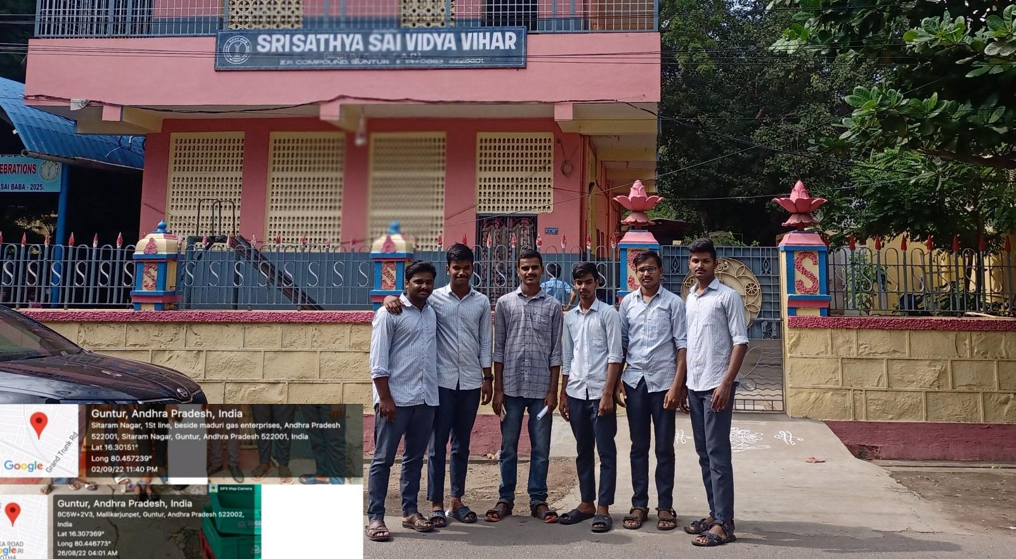

the toes of the right foot pointing directly down, the left foot, center of the pelvis, shoulders and head are all vertically aligned. Hands are typically held above the head either pointed directly upwards and unclasped, or clasped together in anjali mudra.

Theasana is typically held for 20 to 60 seconds, returning to tadasana while exhaling, then repeating standing on the opposite leg.

A 7th-century stone carving in Mahabalipuram appears to contain a figure standing on one leg, perhaps indicating that a pose similar to vrikshasana was in use at that time. It is said that sadhus disciplined themselves by choosing to meditate in the pose.

Tadasana is the basic standing asana on which many other poses are founded. The feet are together and the handsare at the sides of the body.

The posture is entered by standing with the feet together, grounding evenly through the feet and liftingup through the crown of the head. The thighs are lifted, the waist is lifted, and the spine is elongated. The breathing is relaxed.

It is used in some schools of yoga in between other poses, to allow the body and consciousness tointegrate the experience of the preceding asana and to prepare for the next.

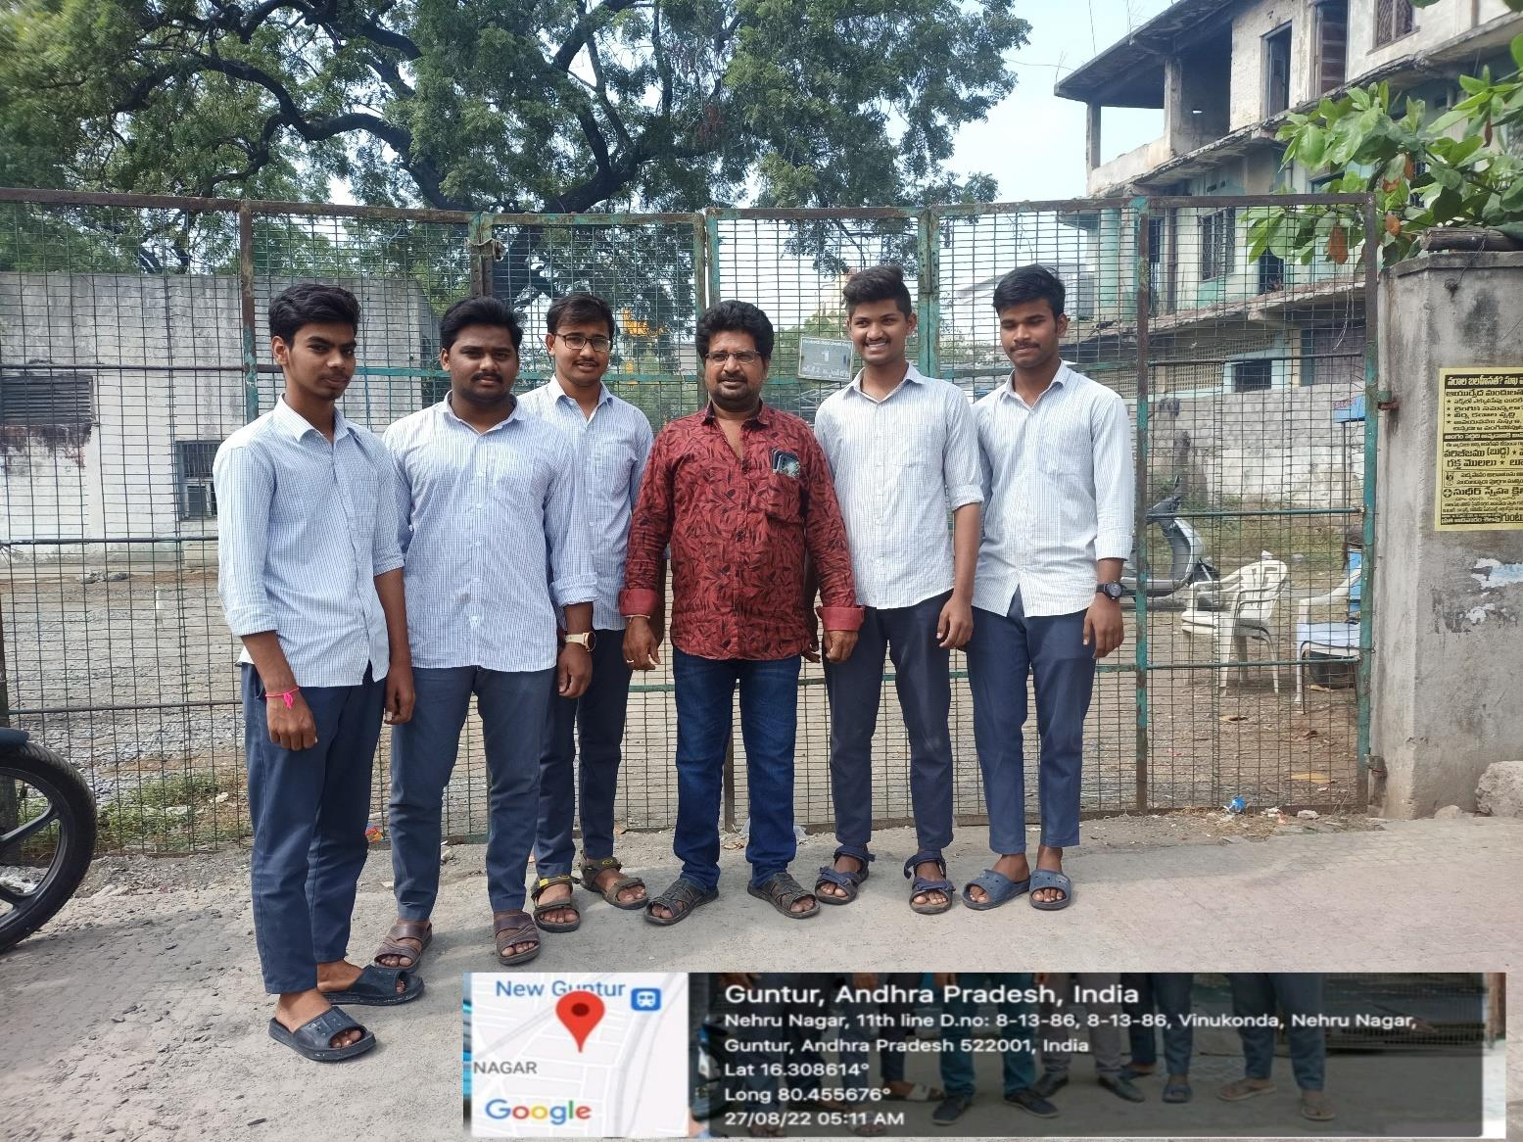Asanas that help prepare for Tadasana include Adho Mukha Svanasana and Uttanasana.

The pose was unknown in hatha yoga until the 20th centuryLight on Yoga, but it appears in the 1896 *Vyayama Dipika*, a manual of gymnastics, as part of the "very old" sequence of *danda* (Sanskritfor "staff" or "stick") exercises.

Norman Sjoman suggests that it was among the poses adopted into modern yoga as

exercise in Mysore by Krishnamacharya to form the "primary foundation" for his vinyasas with flowing movements between poses. The pose was then taken up by his pupils Pattabhi Jois and, intotheir worldwide Ashtanga Vinyasa Yoga and Iyengar Yoga styles respectively.

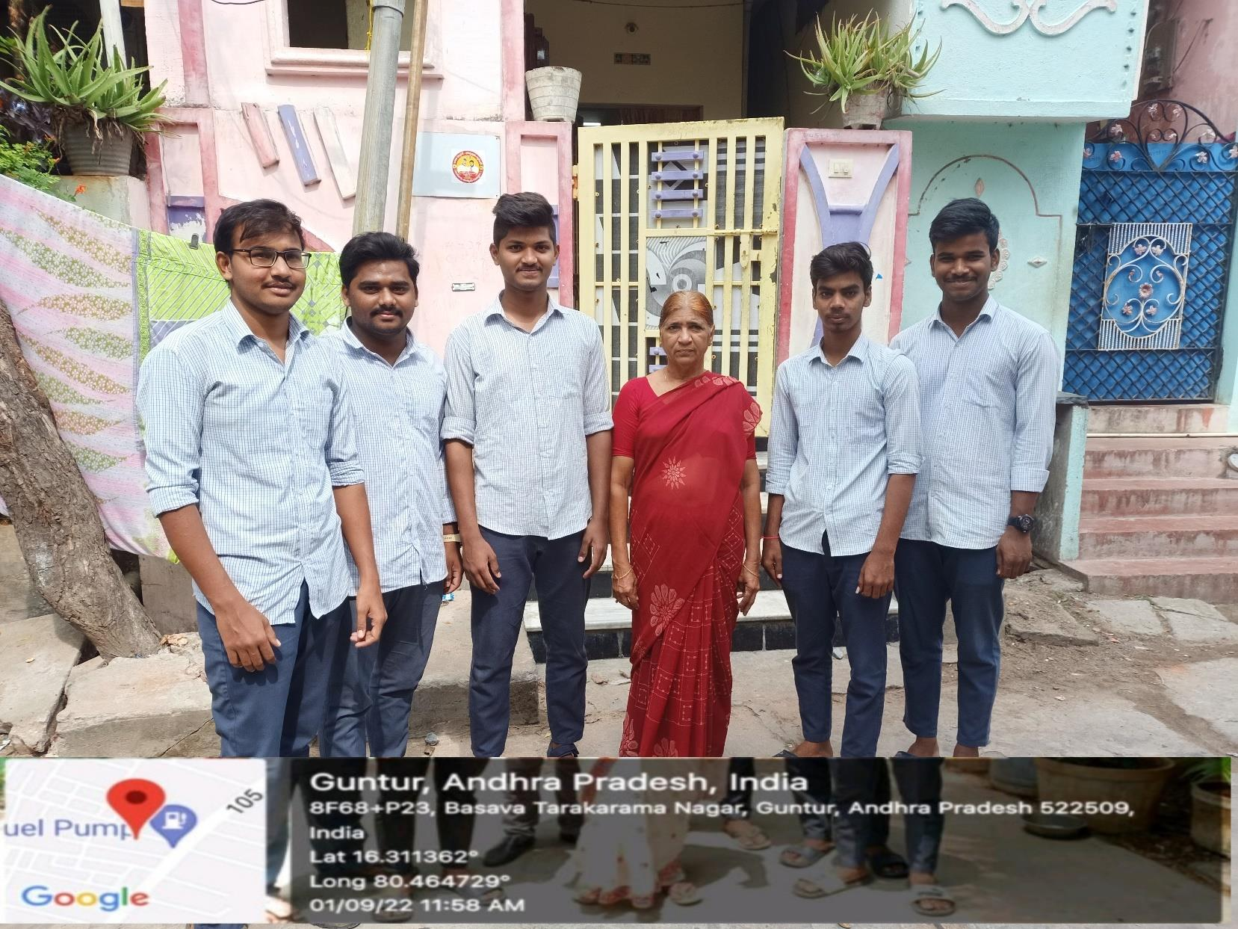

The name comes from the Sanskrit words उष्् Uṣṭra, "camel", and आसन, Asana meaning "posture" or "seat".

A different (standing) pose is given the name Ushtrasana in the 19th century Sritattvanidhi. Themodern pose is described in the 20th century by two of asana

Ustrasana is a deep backward bend from a kneeling position; the completed pose has the hands on the heels. The backs of the feet may be flat on the floor, or the toes may be tucked under for a slightly less strong backbend.

The pose is one of the 26 asanas in the Bikram Yoga sequence

* Provides good blood circulation to all the organs because the whole body engagesin this yoga asana.
* While stretching out your upper body to do Ustrasana, you are essentially stretching out your back and shoulders. This aids in improving your mobility.
* Ustrasana benefits the female body by opening up the pelvic area. This effect canbe linked to reduced menstrual pain in the abdomen, ovaries, etc.
* The asana emphasises the opening up of the leg muscles, ankles, and hamstrings (the muscles at the back of your thighs). These Ustrasana benefits can help preventconditions like varicose veins.
* Toning up the thighs, hips, glutes, and back muscles is a direct result of regularlydoing the camel pose and also holding the pose for about a minute.
* Every yoga pose is done by regulating your breathing pattern. While doing the camel pose, too, you will have to regulate your breathing (while getting into the pose, holding it, and then leaving the pose). This breathing exercise helps enhancelung capacity, which increases the elasticity of the lung tissue.
* While stretching your entire upper body backwards, you engage your core, back,and throat. This has a greater and positive impact on your adrenal, thyroid, pituitary, and pineal glands.
* The energy flow associated with the camel pose helps align and provide energy toyour chakras (the body’s energy centres).
* Ustrasana benefits your body by helping to get rid of fatigue and even anxiety attimes.
* It is also beneficial to get rid of constipation and other abdominal-related issues, asit completely stretches out this particular region.

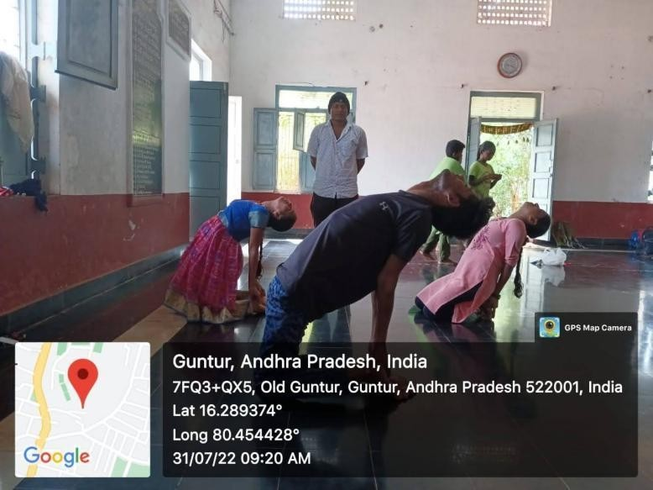

The word “Ardha Matsyendrasana” has been derived from Sanskrit and it translates as “Half Lord of the Fishes Pose”. The Ardha Matsyendrasana Yoga is a seated twist asana that is practiced to improve body posture and restore the digestive system.

The Ardha Matsyendrasana steps are very simple and easy to follow. When done correctly, this yoga has the power to transform your body. Before starting the ardha matsyendrasana, it is essential to warm up for a few minutes. Once this is done, follow the steps below:

* Sit cross-legged on your mat.
* Place the right hand on the left knee while twisting your torso to the left side.
* Twist from the base of your spine to the shoulders.
* Make sure you are not lifting your body off the mat. Also, while stretching, be careful that youdon’t hurt your lower back.
* Your left hand will be placed on the mat, just behind your hips.
* Untwist and repeat the exercise for the other side.
* While performing the Ardha Matsyendrasana steps, ensure that you are very slow whileperforming this asana since fast movements can hurt your neck or your lower back.

1. Helps in the agility of the spine.
2. The poses and postures of this yoga elongate the spine.

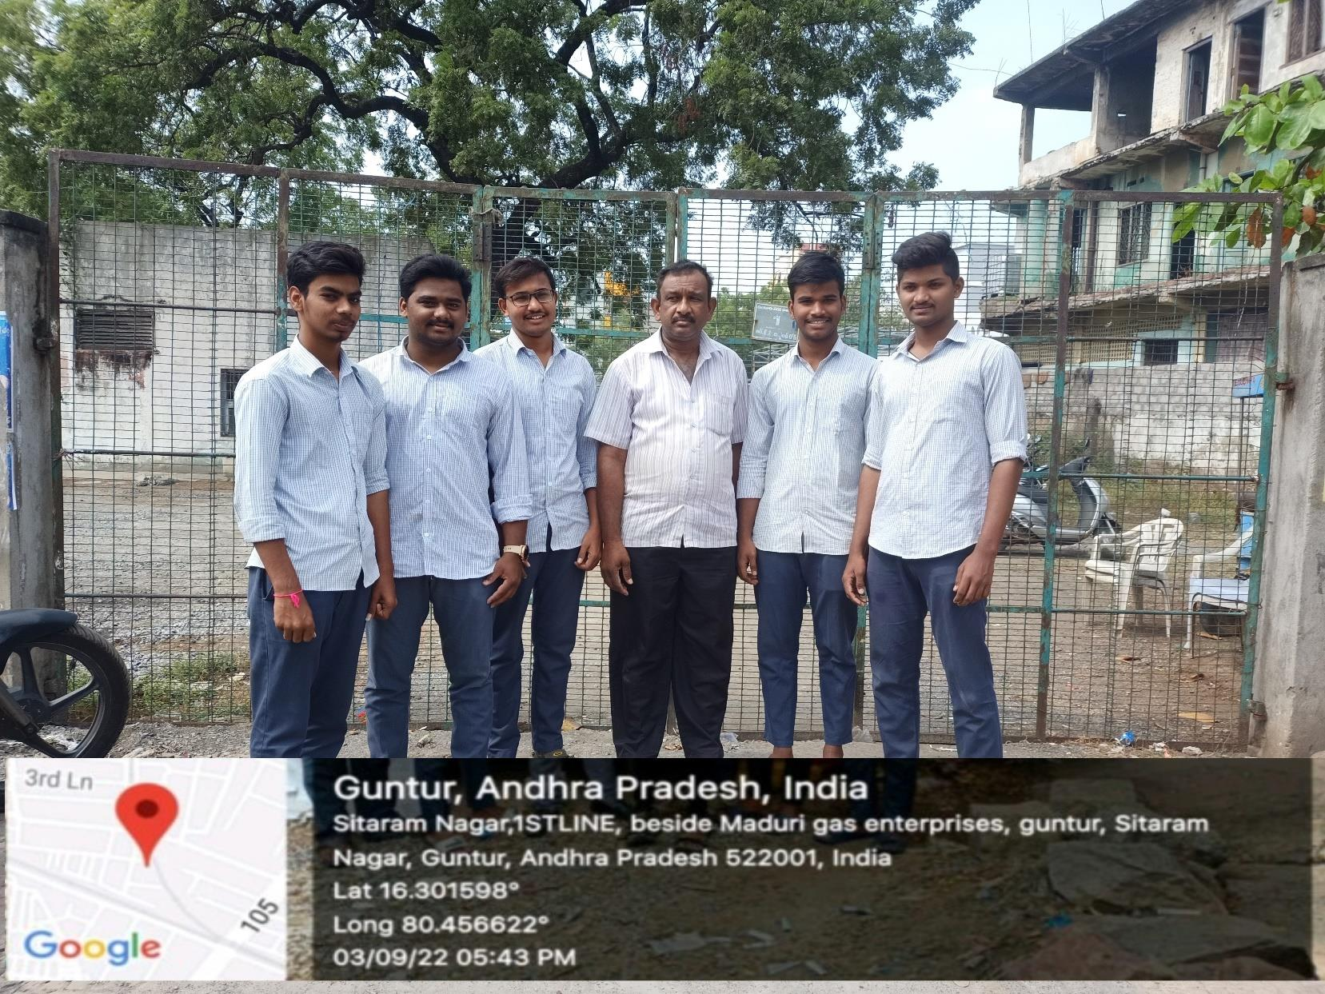

1. Restoration of the natural alignment of the spine.
2. Releases the lower back muscles and provides relief from lower back pain.
3. Aids in maintaining normal rotation of your spinal cord.
4. The Ardha Matsyendrasana Yoga posture helps calm the mind. As a result, you feel de-stressed and can sleep better.

Nadi is called pulse and Shodhana means cleaning. Thus, this pranayama is being done since ancient times to clean the Nadis. It is said that Indian sages used to practice such yogic practices to keep themselves healthy. In simple words, Nadi Shodhana Pranayama is called Alternate Nostril Breathing Exercise, in which one has to breathe through one nostril, hold the breath, and then exhale through another.

The Nadis in the human body are subtle energy channels.Nadi Shodhan Pranayama is a process of breathing that helps to cleanse these energy systems and operate smoothly and thus calm the mind. Some yogis also refer Nadi Shodhana Pranayama as Anulom Vilom Pranayama.

Sit relaxed with a gentle smile on your face. Keep your shoulder loose and spine straight.

Place the left hand on your left knee. Your palm should be open towards the sky or in a chin pose.

Put your middle and index finger between eyebrows. Also, keep your thumb on the right side of the nostril and little finger and ring finger on the left nostril. For opening and closing of the left nostril, ringfinger and little finger will be used. Also, for the right nostril, the process is done by the thumb.

By pressing your right nostril by the thumb, exhale through the left nostril.

After breathing through the left side, press your left portion of the nostril gently with a little and index finger.

Benefits:

* It makes the digestive system strong.
* Nadi shodhan Pranayama is very beneficial for relieving anxiety and stress of the mind.
* High blood pressure/ Hypertension is also overcome by Nadi shodan
* Nadi shodan Pranayama is helpful in reducing weight.
* Blockage in the heart is removed by this asana.

We know this one can be killer, but it’s definitely worth it. Do you know what “utkata” means in Sanskrit? It means fierce, and “asana” means pose. We get Chair Pose from the fact that you mimicthe position of sitting in a chair. Nevertheless, if you’re looking to tone those tired legs, Utkatasanacan bring out your fierce side!

To emphasize the health benefits of this posture, you can try a more advanced variation. Once you are in position, brings your hands together at your heart like you are praying. Twist to the right side, keeping the left elbow outside the right knee. Stay low and keep the knees pressed together. Come back to center and repeat on the opposite side.

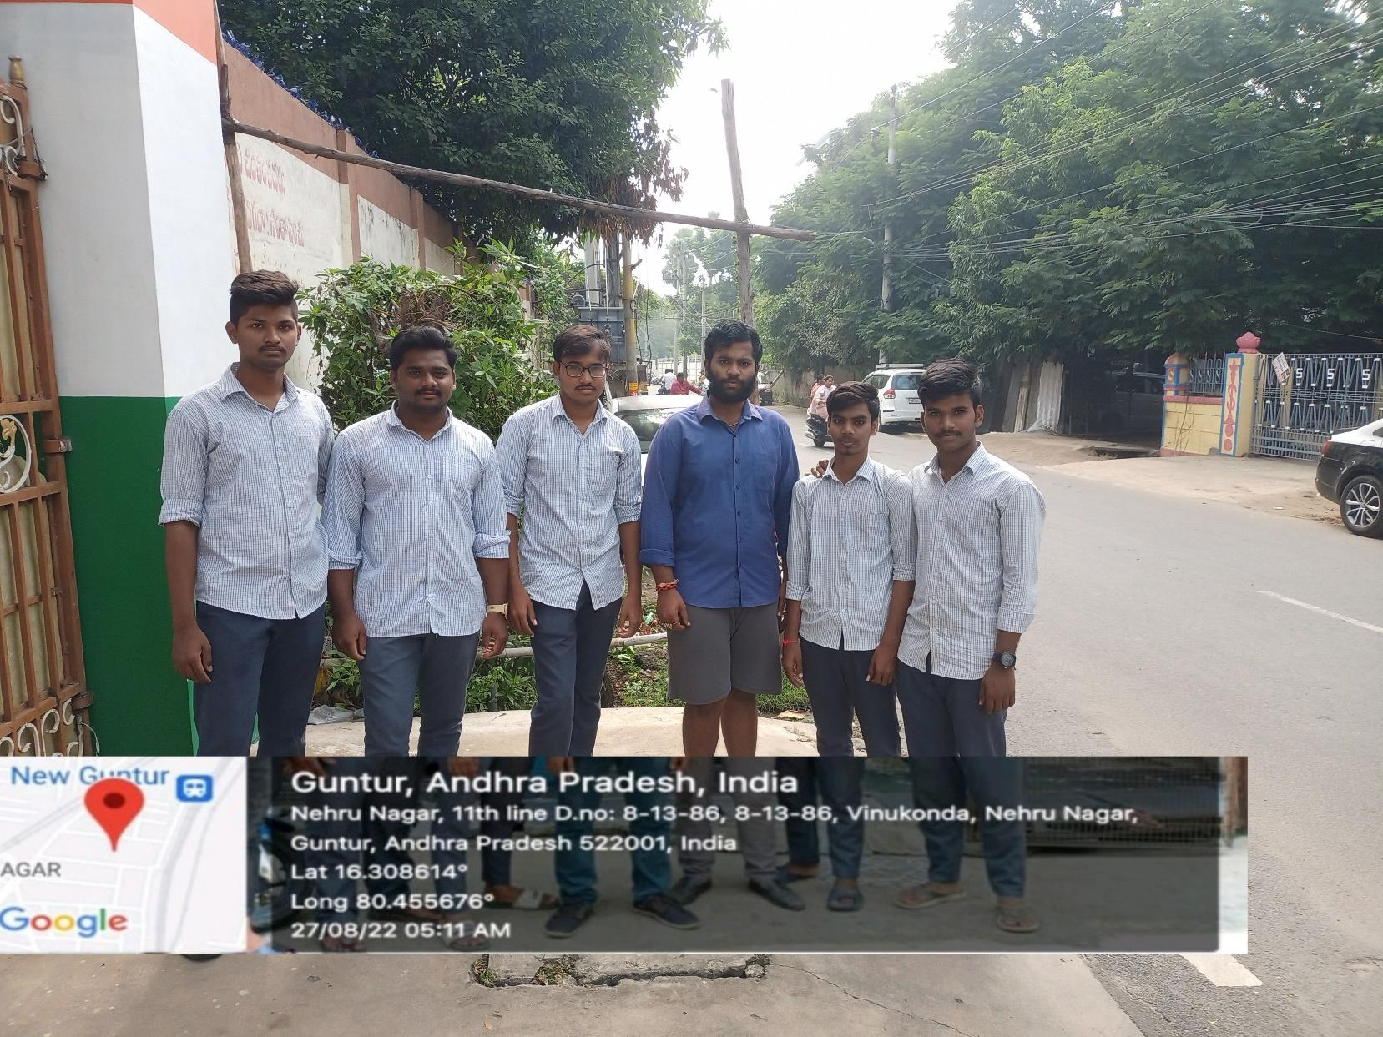

The words Urdhva Mukha Svanasana comes from the Sanskrit language wherein ‘Urdhva’ means Upward, ‘Mukha’ means Face, ‘Svana’ means Dog, and ‘Asana’ means Pose. Thereby, known asUpward Facing Dog pose.

Up Dog Pose, Forward Facing Dog, Upward Dog.

The Upward Dog pose may look simple at first but it can be a challenging pose. You need to ensure that all your muscles are engaged the right way and you follow all the right steps. If you do not

followthe best form, it can lead to muscle injury.

One of the main benefits of Upward Dog Pose is that it helps in stretching your chest, back, legs,thighs, and neck. This improves blood circulation and also relieves back pain.

Since your body weight is balanced on your arms and wrists during Upward Dog Pose, this yoga alsostrengthens the muscles and prevents any future injuries due to wrists’ weakness.

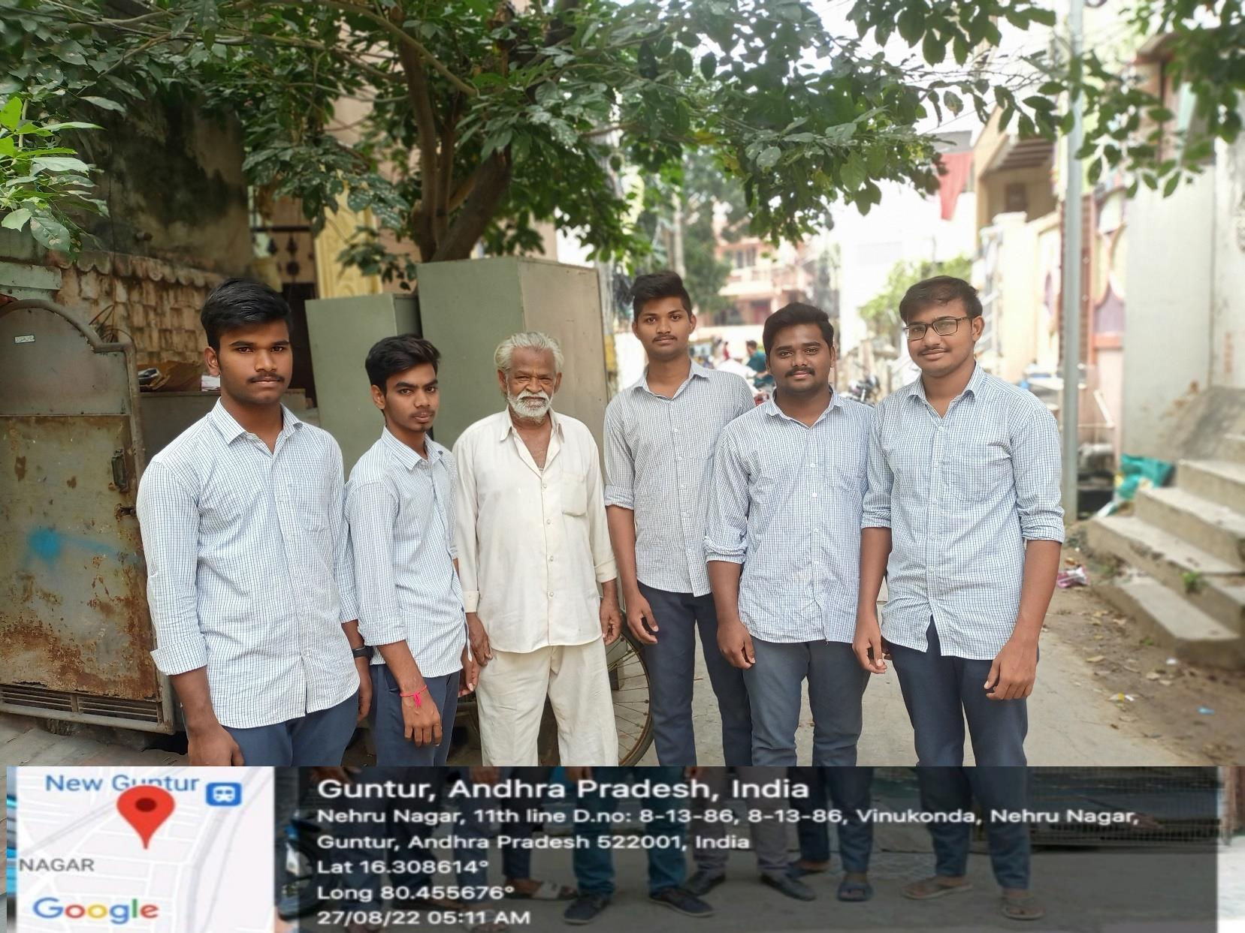

Shashankasana resembles a ‘Hare’ in its final stages and hence the name. Since it has a calming effect on the body and mind, it is also called Sashankasana, Sashanka meaning moon in Sanskrit. It is a popular posture to cure any back related troubles and when practiced regularly can be a boon to tired backs and those with back-related pain. It is a beginner’s pose and can be performed by all age groups.**Blood circulation keeps the body youthful and energetic** – Sashankasana is excellent since it promotes the flow of blood to the head and provides nourishment to the eyes and all functions related to the brain. When practiced regularly, it can be a boost for students and working people alike.

**Fatigue is kept at bay and head related ailments subside** – Because of a reverse flow of blood to the brains, the nerves to the brains are invigorated and the body functions better with optimum energy.The daily grind of everyday life is a thing of the past when this posture is practiced regularly.

**Depression or mental disorders take a backseat** – For those suffering from chronic depression or mental issues, this asana can offer the much needed calmness to the head whilst soothing the nerves of the brain. Since the pose also resembles the fetal position, it builds a sense of security and surrender. For those with emotional balance issues, this pose is recommended to deal with anger and frustration.

*we start our awernese program from my faculty of his name was khasim Basha he was 38 years oldby explaining with the yoga and types of yoga that will be helpful to your health sir.By taking yogatwice a day you will get more brain power and even physical yoga’s asanas. Also their to improve your health for stress relife and the consideration of the as been healthy.*

*By taking the few more steps in your life may be it’s leads to your body fit physical as well as mentally.I can explain him taking 10min yoga in day what you.* Breath should be slow, steady and

controlled. It should not be forced or restricted in anyway.Initially start the practicewithfew repetitions and gradually increase the number of repetitions.

If possible, maintain the ratio of 1:2 for inhalation and exhalation.Follow mentally with awareness as per the instructions given during practices.Keep the eyes closed during thepractice and avoid body movements.

Reduction in sympathetic arousal and reduced emotional distress and improves qualitof sleep.

Rejuvenate the body and helps to keep the mind calm.Meditation helps to

reduces anxiety and stress by reduce the cortisol level and enhance the alpha brain waveMakes the body stable and calm the mind Balance the functions of neuroendocrine

system thereby enhance theimmune system .

Those are the benift’s &tips from my side to the faculty to avoid mental and physical stress .

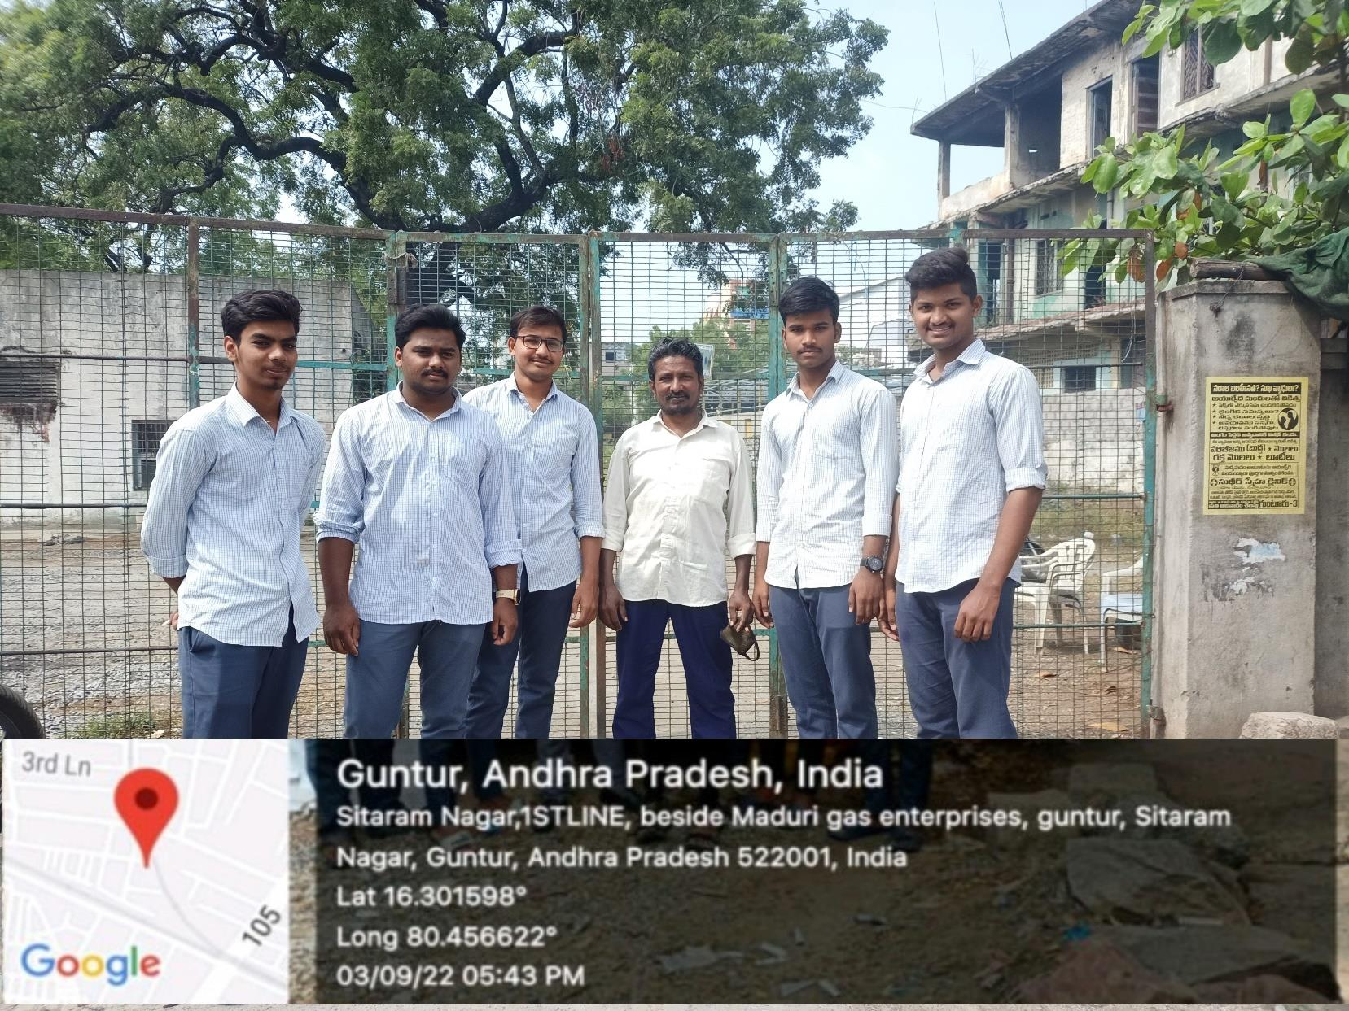

***Yoga Practices for prevention, rehabilitation and to increase immunity.***

|  |  |  |  |  |
| --- | --- | --- | --- | --- |
| S.N  o | **Yoga Practices** | **Do’s** | **Dont ’s** | **Bene fits** |
| **1.** | ShodhanaKriya | Use lukewarm water | Should avoid in | Neti helps in |
|  | (Yogic cleansing | forcleansing. | case ofepistaxis, | cleansingsinuses, |
|  | practices) | Jalneti must be | middle ear | beneficial in |
|  | Jalaneti, Sutra | followedby | infection, and | allergic conditions |
|  | Neti, | kapalabhati to | recent ENT | andreduces upper |
|  |  | removeall water | surgery. | airway |
|  |  | from nasal passage. Neti, is advised to practice weekly once ortwice. |  | reactivity)(13,15) |
| **2.** | Yogic  SūkṣmaVyāyām | Move the joints as  far aspossible. | Do not over strain.  Avoid this practice | Joint movements  help toincrease |
|  | as / | Do it slowly with | in case of severe | blood circulation |
|  | shithilikaranavy | breathawareness | joint painand | and reduce stiffness |
|  | ayamas/ |  | illness. | which enhance joint |
|  | Pawanamuktasa |  |  | flexibility. |
|  | na series (Joint |  |  | Helps to facilitate |
|  | movements): |  |  | asanapractices. |
|  | Neck  movements |  |  |  |
|  | Shoulder |  |  |  |
|  | rotation Trunk |  |  |  |
|  | movement Knee |  |  |  |
|  | movement  Ankle rotation |  |  |  |
| **3.** | Yogasana:  Standing, Sitting, Prone&Supi ne lying | Do it with breath awareness.  Cardiac patients shall dowith care as advised by Yoga experts.  Asanas that involve chestexpansion preferred  Simplified version/s shall be followed be beginnersand elderly population | Please avoid this practice in case of cardiac disorders, abdominal hernia,inflammation, ulcers, recent abdominalsurgery & vertigo.  Hypertensive patients should bend with care. Do not try to bend beyond the limits and donot  overdo the lateral stretch. | Ushtrasana, UtthanaMandukasa na, Tadasana, Trikonasana, Vakrasana, Bhujangasana, Sarala Matsyasanaetc. practicesimproves chest expansion and cardio- pulmonary functions.(16). |
| **4.** | Kapalabhati | 40-60 strokes  perminute | Hypertensive, cardiac problems, | Improves pulmonary |

|  |  |  |  |  |
| --- | --- | --- | --- | --- |
|  |  |  | patients with | functions and |
| respiratory | reducessecretions. |
| distress,slipped disc | Very useful |
| patients should not | preparatorypractice |
| do it. | for pranayama |
| Better to practice | practice |
| it early in the | Helps to cleanse |
| morningon an empty stomach | frontalsinuses. |

I went to Basava Tarakarama Nagar in the part of awareness.we vist a old women her name was G.anjamma garu.she was 45 years old and she didn’tknow the yoga and what she benefit’s from the yoga so me and my team members so based on my project we asked some questios did you know the yoga and she said that she was nothing no about yoga .we explain to her the yoga is the very good prevention of many disease and you can control your mind through yoga .

Did you feel stress in your life daily right when your in stress the yoga will helps you a lot for to re-construct your day with smile so please do yoga .

The main and majior role of yoga was to keep the mind free and physicall fit with your body .Even when your in unhealthy .The yoga will helps you a lot the main and majior thing is to create the life with the smile of yoga and that will be happen by the deadication of practice.

# 10 MINUTES YOGA

|  |  |  |  |
| --- | --- | --- | --- |
| **COMMON YOGA PROTOCOL - 10 MINUTES** | | | |
|  | Practices | Name of the Practice | Duration (Minutes  ) |
| A | Starting | Prayer | 30 seconds |
| B | Loosening Practices (SukṣmaVyāyāma / CālanaKriyā) | Neck Bending | 2 minutes |
| Shoulder movement |
| Trunk Movement |
| C | Yoga Practices |  |  |
|  | Āsanas performedin standing posture | Tadāsana (The Palm tree posture) | 1 minute |
| ArdhaChakrāsana (The Half wheel posture) | 1 minute |
| Āsana performedin sitting posture | Sasakāsana (The Hare posture) | 1 minute |
| Āsana performed while lying on thestomach | Bhujangāsana (The Cobra posture) | 1 minute |
| Āsana performed while lying on theback | PawanaMuktāsana (The Wind releasing posture) | 1 minute |
| D | Pranayama | (AnulomaViloma /Nadiswhodhana Pranayama)The Alternate nostril breathing (2 rounds) | 1 minutes |
| E | Dhyāna | The Meditation | 1 minutes |
|  | Closing | Sankalpa/ Shanti patha | 30 seconds |
|  | TOTAL DURATION | | 10 minutes |
|  |  | |  |

##### CHAPTER 6: RECOMMENDATIONS AND CONCLUSIONS OF THE MINIPROJECT

For the younger generation the yoga is such a wonder full opportunity for to lead their life sucessfullyand taking proud & healthy the life yoga will in the younger generation so we have consult the high recommeded to the people who is willing want to know about the yoga for we and facing so many circumstances for to aviod those things with a very good manner.

Yoga is a discipline based on an extremely subtle science, which focuses on bringing harmony between mind and body. It is an art and science of healthy living. Yoga leads to a perfect harmony between mind and body, man and nature, individual consciousness and universal consciousness. Yoga helps to build up psycho- physiological health, emotional harmony; and manage daily stress and its consequences. Yoga is also useful in conditions where stress is believed to play a role.Various yogicpractices such as Yogasanas, Pranayama, Dhyana (meditation), cleansingand relaxation practices etc. are known help modulate the physiological response to stressors. Several randomized controlled studies have shown the efficacy of Yogic practices in management of non-communicable diseases like hypertension , Chronic Obstructive Pulmonary disease (COPD), bronchial asthma, diabetes , sleep disorders, depression , obesity, etc. that can be comorbid conditions in patients with COVID 19.

Yoga has also been shown to be useful in vulnerable population such as elderly, children. The function of the immune system is critical in the human response toinfectiousdisease. A growing body of evidence identifies stress as a cofactorin infectious disease susceptibility and outcomes.

Studies on yoga in managing flu symptoms during an Influenza season have shown promising results. A recent randomized trial comparing meditation and exercise with wait-list control among adults aged 50 years and older found significant reductions in ARIillness during cold season with mindfulness meditation. Yogais also known to increase mucosal immunity by increasing Salivary Beta Defensin-2 levels in elderly population Considering that they are a vulnerable group to contract such infections, yoga may be useful as a preventive measure.

Yoga practices such as Kriya, Yogasana and Pranayama have been shown to reduce airway reactivity in elderly subjects with asthma and COPD . Thus, sufficient evidence exists to justify testing the hypothesis that training in Yoga /Meditation can reduce susceptibility to ARI illness. Neti kriya isuseful in acute coryza and symptoms of cold .

The purpose of Yoga is to create harmony in the physical, vital, mental, psychological and spiritual aspects of the human being. In the foregoing pages of this book, I have described the Technique of relaxation in different postures viz., standing, lying and sitting postures which brings in this harmony. Yoga is not mere practice for an hour or two in a day but it is the most scientific way of living, all the twenty-four hours of the day. During the whole day you may be only in one of these three postures and hence a skilful adjustment in them will effect the required harmony.

"Yogasthah Kuru Karmani- Be established in Yoga and do all your duties." "Yogah karmasu Kausalam-Yoga is skill in action." Skill here means to be in tune with the nature of the Supreme Reality.

Be a Yogin always, is the loving instruction of Lord Krishna. Convert life into Yoga, so that you may ensure success in all the fields of activity. By regular practice, by using your presence of mind, skill and wisdom, you can become Yogins and enjoy happiness and peace, whatever be the circumstances and conditions in which you are placed.

Yoga is a well-known term these days, it is called a spiritual discipline that is based on a subtlescience that aims at attaining harmony between body and mind.

This is also referred to as science and art for achieving healthy living. The derivation of the word yogais considered from the Sanskrit word Yuj. The meaning of Yuj is to join or yoke is to unite.

Yoga is safe and is practised even by kids and older people. There is no use of hard equipment, but only movements of the body for the extension. Yoga gives relaxation to not only the mind but also flexibility to the body.

The students are also taught the benefits of yoga in their curriculum. Have you ever got the task of writing an essay on yoga? How are you going to write it? Well, the first thing that will appear in your mind is the benefits of yoga to include in the yoga essay. It is like writing an essay on other topics - you will have to write a perfect title, a comprehensive introduction, the body of the essay, and an appealing conclusion.

In India, the practice of yoga started centuries ago. In the present times as well, it is followed by many due to its benefits for health as well as the overall life. Yoga has made several changes in the lifestyle of people. This is the inheritance embraced by centuries and will keep going for years. From working individuals to celebrities, everyone practices yoga to maintain a balanced life. Yoga helps to unite people in harmony and peace.

Centuries ago, people belonging to Hinduism, Buddhism and Jainism started the following yoga and continued even now. Over the years, yoga experts have discovered different types of yoga offering numerous benefits. India is currently the centre stage of yoga and people from other countries visit India to practice it.

Currently, when the whole world is fighting against Coronavirus, yoga has gained its importance. The craze of yoga among people has increased so much and people are ready to join it via digital mode. Breathing practices have become a common practice for people as the medicines have not been introduced for the deadly virus. Several mudras and postures are also recommended by the doctors during this time.

**SADILAJA/CĀLANA KRIYĀS /LOOSENING PRACTICES :**

The Cālana Kriyās/loosening practices/Yogic Sūkṣma Vyāyāmas help to increase microcirculation. These practices can be done while standing andsitting.

1. **NECK BENDING**(Grivā Śakti Vikāsaka) ***Sthiti:*** *Samasthiti*( Alert Posture)

Technique

##### Stage i: (Forward and Backward Bending/Stretching)

* + Stand with the feet 2-3 inches apart. Keep the hands straight beside the body.
  + This is **Samasthiti.**This is also called **Tāḍāsana.**
  + Keep your palms on the waist.
  + While exhaling, move the head forward slowly and try to touch the chin to the chest.
  + While inhaling, move the head upand bend back comfortably.
  + This is one round: repeat 2 more rounds.

##### Stage - ii : (Right and Left bending/Stretching)

* + While exhaling, bend the
  + head slowly to the right;
  + bring the ear as close as possible to the shoulder without raising the shoulder.
  + While inhaling, bring the head to the normal position.
  + Similarly, while exhaling bend the head to the left side.
  + Inhale and bring the head up to normal position.
  + This is one round: repeat 2 more rounds.

##### Stage - iii : (Right and Left Twisting)

* + While exhaling, gently Keep the head upright.
  + turn the head to the right so that the chin is in line with the shoulder.
  + While inhaling, bring the head to the normal position.
  + Similarly, while exhaling, turn the head to the left.
  + Inhale and bring the head to the normal position.
  + This is one round: repeat 2 more rounds.

##### Stage iv: Neck Rotation

* + Exhale; bend the head forward to touch the chin to the chest.
  + Inhale; slowly rotate the head clockwise in a circular motion, exhale while coming down.
  + Do a full rotation.
  + Then rotate the head in an anti-clockwise direction.
  + Inhale; go back and exhale, come down.
  + This is one round: repeat 2 more rounds.

##### Note:

* + Move the head as far as possible. Do not over strain.
  + Keep the shoulders relaxed and steady.
  + Feel the stretch around the neck and loosening up of the joints and muscles of the neck.
  + Can also be practiced sitting on a chair.
  + People with neck pain can do the practice gently especially when taking the head back to

theextent it is comfortable.

* + Elderly people and persons with chronic cervical spondylitis may avoid these practices.

1. **SHOULDER'S MOVEMENT*Sthiti:***

*Samasthiti*(Alert Posture) **Stage i:**

##### (Shoulder's Stretch) Technique:

* + Keep the feet together, the body straight and the arms by the sides.
  + While inhaling; raise your both arms sideways above your head with the palm outward.
  + Exhale and bring it down in the same manner.
  + Palms must be opened, with fingers together.

##### Stage ii: Skandha Cakra (shoulder Rotation)

* + Stand erect.
  + Place the fingers of left hand on the left shoulder and the fingers of right hand on the

rightshoulder.

* + Full rotation of the both elbows in a circular manner.
  + Inhale and raise your elbows & bring them back when you exhale.
  + Try to touch the elbows in front of the chest on the forward movement, stretch the elbows back

inthe backward movement and touch the side of the trunk while coming down.

* + Repeat this 2 times rotating from front to back.
  + Do the same in reverse manner. Inhale while raising the elbows & exhale while bringing

themdown.

##### Benefits:

* + Practice of this Yogic kriyā makes the bones, muscles and nerves of the neck and shoulderhealthy.
  + These practices are helpful in cervical spondylosis and frozen shoulder.

1. **TRUNK MOVEMENT** (Kaṭiśakti Vikāsaka)

***Sthiti:*** *Samasthiti* (Alert Posture)

##### Technique

* + Keep the legs about 2-3 feet apart.
  + Raise both the arms up to shoulder level with palms facing each other and keep them parallel.
  + While exhaling, twist the body towards the left side so that the right palm touches the leftshoulder, come back with inhalation.
  + While exhaling, twist the body towards the right side so that the left palm touches the rightshoulder, come back with inhalation.
  + This is one round: repeat it two more times.
  + Relax in*Samasthiti*

##### Note:

* + Do it slowly with coordination of breathing.
  + Cardiac patients shall do with care.
  + Avoid this practice in case of severe back pain, vertebral and intervertebral disc disorders

andduring menstruation.

1. **KNEE MOVEMENT Sthiti:** *Samasthiti*(Alert Posture)**Technique**
   * Inhale; lift your arms up to the shoulder level, palms facing downwards.
   * Exhale; bend the knees and bring down the body to the semi squatting position.
   * In the final position, both the arms and thighs should be parallel to the ground.
   * Inhale; and straighten the body.
   * Exhale while bringing down the hands.
   * Repeat it two more times.

##### Note:

* + Helps to strengthen knees and hip joints.Avoid this asana in case of acute conditions of arthritis

# 20 MINUTES YOGA

|  |  |  |  |
| --- | --- | --- | --- |
| **II** | **COMMON YOGA PROTOCOL - 20 MINUTES** | | |
|  | Practices | Name of the Practice | Duration (Minutes) |
| A | Starting | Prayer | 30 seconds |
| B | Loosening Practices (SukṣmaVyāyāma / CālanaKriyā) | Neck Bending | 2.5 minutes |
| Shoulder movement |
| Trunk Movement |
| C | Yoga Practices |  |  |
|  | Āsanas performed in standing posture | Tadāsana (The Palm tree posture) | 1 minute |
| PadaHatasana(The Hands to the feet posture)/ ArdhaChakrāsana (The Half wheel posture) | 2 minutes |
| Trikonāsana (The Triangle posture) | 1 minute |
| Āsanas performed in sitting posture | Bhadrāsana (The Firm/Auspicious posture) | 1 minute |
| ArdhaUshtrāsana (The Half camel posture ) | 1 minute |
| Sasakāsana (The Hare posture ) | 1 minute |
| Vakrāsana (The Seated twist posture) | 1 minute |
| Āsana performed while lying on the stomach | Bhujangāsana (The Cobra posture) | 1 minute |
| Āsana performed while lying on the back | PawanaMuktāsana (The Wind releasing posture) | 1 minute |
| D | Kriya | Kaphalabhati (The Shining skull practice ) 1 rounds,30 cycles each | 1 minute |
| E | Pranayama | AnulomaViloma Pranayama (The Alternate nostrilbreathing) (5 rounds) | 2 minutes |
| Bhramari Pranayama(BhramariRechaka) (The Beesound breathing) (3 rounds) | 1.5 minutes |
| F | Dhyāna | The Meditation | 2 minutes |
|  | Closing | Sankalp/ Shanti patha | 30 seconds |
|  | TOTAL DURATION | | 20 minutes |

**45 MINUTES YOGA**

|  |  |  |  |
| --- | --- | --- | --- |
| **III** | **COMMON YOGA PROTOCOL - 45 MINUTES** | | |
|  | Practices | Name of the Practice | Duration (Minutes) |
| A | Starting | Prayer | 1 |
| B | Loosening Practices (SukṣmaVyāyāma / CālanaKriyā) | Neck Bending | 2 |
| Shoulder movement | 2 |
| Trunk Movement | 1 |
| Knee Movement | 1 |
| C | Yoga Practices |  |  |
|  | Āsanas performedin standing posture | Tadāsana (The Palm tree posture ) | 1 |
| Vrikshāsana (The Tree posture) | 2 |
| Pada-hastāsana (The Hands to the feet posture) | 1 |
| ArdhaChakrāsana (The Half wheel posture) | 1 |
| Trikonāsana (The Triangle posture) | 2 |
| Āsanas performedinsitting posture | Bhadrāsana (The Firm/auspicious posture) | 1 |
| Vajrāsana The Thunderbolt/diamond posture) | 1 |
| ArdhaUshtrāsana (The Half camel posture ) | 1 |
| Ushtrāsana (The Camel posture ) | 1 |
| Sasakāsana (The Hare posture) | 1 |
| UtthanaMandukāsana (The Stretched up-frog posture ) | 1 |
| Vakrāsana (The Seated twist posture) | 2 |
| Āsanas performed while lying on the stomach | Makarāsana (The Crocodile posture ) | 1 |
| Bhujangāsana (The Cobra posture) | 1 |
| Shalabhāsana (The Locust posture) | 1 |
| Āsanas performed while lying on the back | Setubandhāsana (The Bridge posture ) | 1 |
| Utthanapadāsana (The Raised leg posture) | 0.5 |
| ArdhaHalāsana (The Half plough posture) | 0.5 |
| PawanaMuktāsana (The Wind releasing posture ) | 2 |
| Shavāsana (The Corpse posture ) | 2 |
| D | Kriya | Kaphalabhati (The Shining skull practice ) | 2 |
| E | Pranayama | AnulomaViloma Pranayama (The Alternate nostrilbreathing | 2 |
| Ujjayee Pranayama (The Hissing breathing) (5 rounds) | 2 |
| (Bhramari Pranayama) (BhramariRechaka )The Bee sound breathing) (5 rounds) | 2 |
| F | Dhyāna | The Meditation | 5 |
|  | Closing | Sankalpa shanti patha | 1 |
|  | TOTAL DURATION | | 45 |

**Student Name: Registration No:**

**Period of CSP: From: To: Date of Evaluation:**

**Name of the Person in-charge: Address with mobile number:**

#### Evaluation by the Person in-charge in the Community / Habitation

Please rate the student’s performance in the following areas:

Please note that your evaluation shall be done independent of the Student’s self- evaluation

Rating Scale: 1 is lowest and 5 is highest rank

|  |  |  |  |  |  |
| --- | --- | --- | --- | --- | --- |
| 1 Oral communication | 1 | 2 | 3 | 4 | 5 |
| 2 Written communication | 1 | 2 | 3 | 4 | 5 |
| 3 Proactiveness | 1 | 2 | 3 | 4 | 5 |
| 4 Interaction ability with community | 1 | 2 | 3 | 4 | 5 |
| 5 Positive Attitude | 1 | 2 | 3 | 4 | 5 |
| 6 Self-conNidence | 1 | 2 | 3 | 4 | 5 |
| 7 Ability to learn | 1 | 2 | 3 | 4 | 5 |
| 8 Work Plan and organization | 1 | 2 | 3 | 4 | 5 |
| 9 Professionalism | 1 | 2 | 3 | 4 | 5 |
| 10 Creativity | 1 | 2 | 3 | 4 | 5 |
| 11 Quality of work done | 1 | 2 | 3 | 4 | 5 |
| 12 Time Management | 1 | 2 | 3 | 4 | 5 |
| 13 Understanding the Community | 1 | 2 | 3 | 4 | 5 |
| 14 Achievement of Desired Outcomes | 1 | 2 | 3 | 4 | 5 |
| **15 OVERALL PERFORMANCE** | **1** | **2** | **3** | **4** | **5** |

**Date: Signature of the Supervisor**

**Student Name: Registration No:**

**Period of CSP: From: To: Date of Evaluation:**

**Name of the Person in-charge: Address with mobile number:**

#### Evaluation by the Person in-charge in the Community / Habitation

Please rate the student’s performance in the following areas:

Please note that your evaluation shall be done independent of the Student’s self- evaluation

Rating Scale: 1 is lowest and 5 is highest rank

|  |  |  |  |  |  |
| --- | --- | --- | --- | --- | --- |
| 1 Oral communication | 1 | 2 | 3 | 4 | 5 |
| 2 Written communication | 1 | 2 | 3 | 4 | 5 |
| 3 Proactiveness | 1 | 2 | 3 | 4 | 5 |
| 4 Interaction ability with community | 1 | 2 | 3 | 4 | 5 |
| 5 Positive Attitude | 1 | 2 | 3 | 4 | 5 |
| 6 Self-conNidence | 1 | 2 | 3 | 4 | 5 |
| 7 Ability to learn | 1 | 2 | 3 | 4 | 5 |
| 8 Work Plan and organization | 1 | 2 | 3 | 4 | 5 |
| 9 Professionalism | 1 | 2 | 3 | 4 | 5 |
| 10 Creativity | 1 | 2 | 3 | 4 | 5 |
| 11 Quality of work done | 1 | 2 | 3 | 4 | 5 |
| 12 Time Management | 1 | 2 | 3 | 4 | 5 |
| 13 Understanding the Community | 1 | 2 | 3 | 4 | 5 |
| 14 Achievement of Desired Outcomes | 1 | 2 | 3 | 4 | 5 |
| **15 OVERALL PERFORMANCE** | **1** | **2** | **3** | **4** | **5** |

**Date: Signature of the Supervisor**

**Student Name: Registration No:**

**Period of CSP: From: To: Date of Evaluation:**

**Name of the Person in-charge: Address with mobile number:**

#### Evaluation by the Person in-charge in the Community / Habitation

Please rate the student’s performance in the following areas:

Please note that your evaluation shall be done independent of the Student’s self- evaluation

Rating Scale: 1 is lowest and 5 is highest rank

|  |  |  |  |  |  |
| --- | --- | --- | --- | --- | --- |
| 1 Oral communication | 1 | 2 | 3 | 4 | 5 |
| 2 Written communication | 1 | 2 | 3 | 4 | 5 |
| 3 Proactiveness | 1 | 2 | 3 | 4 | 5 |
| 4 Interaction ability with community | 1 | 2 | 3 | 4 | 5 |
| 5 Positive Attitude | 1 | 2 | 3 | 4 | 5 |
| 6 Self-conNidence | 1 | 2 | 3 | 4 | 5 |
| 7 Ability to learn | 1 | 2 | 3 | 4 | 5 |
| 8 Work Plan and organization | 1 | 2 | 3 | 4 | 5 |
| 9 Professionalism | 1 | 2 | 3 | 4 | 5 |
| 10 Creativity | 1 | 2 | 3 | 4 | 5 |
| 11 Quality of work done | 1 | 2 | 3 | 4 | 5 |
| 12 Time Management | 1 | 2 | 3 | 4 | 5 |
| 13 Understanding the Community | 1 | 2 | 3 | 4 | 5 |
| 14 Achievement of Desired Outcomes | 1 | 2 | 3 | 4 | 5 |
| **15 OVERALL PERFORMANCE** | **1** | **2** | **3** | **4** | **5** |

**Date: Signature of the Supervisor**

**Student Name: Registration No:**

**Period of CSP: From: To: Date of Evaluation:**

**Name of the Person in-charge: Address with mobile number:**

#### Evaluation by the Person in-charge in the Community / Habitation

Please rate the student’s performance in the following areas:

Please note that your evaluation shall be done independent of the Student’s self- evaluation

Rating Scale: 1 is lowest and 5 is highest rank

|  |  |  |  |  |  |
| --- | --- | --- | --- | --- | --- |
| 1 Oral communication | 1 | 2 | 3 | 4 | 5 |
| 2 Written communication | 1 | 2 | 3 | 4 | 5 |
| 3 Proactiveness | 1 | 2 | 3 | 4 | 5 |
| 4 Interaction ability with community | 1 | 2 | 3 | 4 | 5 |
| 5 Positive Attitude | 1 | 2 | 3 | 4 | 5 |
| 6 Self-conNidence | 1 | 2 | 3 | 4 | 5 |
| 7 Ability to learn | 1 | 2 | 3 | 4 | 5 |
| 8 Work Plan and organization | 1 | 2 | 3 | 4 | 5 |
| 9 Professionalism | 1 | 2 | 3 | 4 | 5 |
| 10 Creativity | 1 | 2 | 3 | 4 | 5 |
| 11 Quality of work done | 1 | 2 | 3 | 4 | 5 |
| 12 Time Management | 1 | 2 | 3 | 4 | 5 |
| 13 Understanding the Community | 1 | 2 | 3 | 4 | 5 |
| 14 Achievement of Desired Outcomes | 1 | 2 | 3 | 4 | 5 |
| **15 OVERALL PERFORMANCE** | **1** | **2** | **3** | **4** | **5** |

**Date: Signature of the Supervisor**

**Student Name: Registration No:**

**Period of CSP: From: To: Date of Evaluation:**

**Name of the Person in-charge: Address with mobile number:**

#### Evaluation by the Person in-charge in the Community / Habitation

Please rate the student’s performance in the following areas:

Please note that your evaluation shall be done independent of the Student’s self- evaluation

Rating Scale: 1 is lowest and 5 is highest rank

|  |  |  |  |  |  |
| --- | --- | --- | --- | --- | --- |
| 1 Oral communication | 1 | 2 | 3 | 4 | 5 |
| 2 Written communication | 1 | 2 | 3 | 4 | 5 |
| 3 Proactiveness | 1 | 2 | 3 | 4 | 5 |
| 4 Interaction ability with community | 1 | 2 | 3 | 4 | 5 |
| 5 Positive Attitude | 1 | 2 | 3 | 4 | 5 |
| 6 Self-conNidence | 1 | 2 | 3 | 4 | 5 |
| 7 Ability to learn | 1 | 2 | 3 | 4 | 5 |
| 8 Work Plan and organization | 1 | 2 | 3 | 4 | 5 |
| 9 Professionalism | 1 | 2 | 3 | 4 | 5 |
| 10 Creativity | 1 | 2 | 3 | 4 | 5 |
| 11 Quality of work done | 1 | 2 | 3 | 4 | 5 |
| 12 Time Management | 1 | 2 | 3 | 4 | 5 |
| 13 Understanding the Community | 1 | 2 | 3 | 4 | 5 |
| 14 Achievement of Desired Outcomes | 1 | 2 | 3 | 4 | 5 |
| **15 OVERALL PERFORMANCE** | **1** | **2** | **3** | **4** | **5** |

**Date: Signature of the Supervisor**

#### Student Self-Evaluation for the Community Service Project

|  |
| --- |
| **Student Name: Registration No:**  **Period of CSP: From:**  **To:Date of Evaluation:** |

##### Please rate your performance in the following areas:

**Rating Scale: Letter grade of CGPA calculation to be provided**

|  |  |  |  |  |  |
| --- | --- | --- | --- | --- | --- |
| 1 Oral communication | 1 | 2 | 3 | 4 | 5 |
| 2 Written communication | 1 | 2 | 3 | 4 | 5 |
| 3 Proactiveness | 1 | 2 | 3 | 4 | 5 |
| 4 Interaction ability with community | 1 | 2 | 3 | 4 | 5 |
| 5 Positive Attitude | 1 | 2 | 3 | 4 | 5 |
| 6 Self-conNidence | 1 | 2 | 3 | 4 | 5 |
| 7 Ability to learn | 1 | 2 | 3 | 4 | 5 |
| 8 Work Plan and organization | 1 | 2 | 3 | 4 | 5 |
| 9 Professionalism | 1 | 2 | 3 | 4 | 5 |
| 10 Creativity | 1 | 2 | 3 | 4 | 5 |
| 11 Quality of work done | 1 | 2 | 3 | 4 | 5 |
| 12 Time Management | 1 | 2 | 3 | 4 | 5 |
| 13 Understanding the Community | 1 | 2 | 3 | 4 | 5 |
| 14 Achievement of Desired Outcomes | 1 | 2 | 3 | 4 | 5 |
| **15 OVERALL PERFORMANCE** | **1** | **2** | **3** | **4** | **5** |

**Date: Signature of the Student**

#### Student Self-Evaluation for the Community Service Project

|  |
| --- |
| **Student Name: Registration No:**  **Period of CSP: From:**  **To:Date of Evaluation:** |

##### Please rate your performance in the following areas:

**Rating Scale: Letter grade of CGPA calculation to be provided**

|  |  |  |  |  |  |
| --- | --- | --- | --- | --- | --- |
| 1 Oral communication | 1 | 2 | 3 | 4 | 5 |
| 2 Written communication | 1 | 2 | 3 | 4 | 5 |
| 3 Proactiveness | 1 | 2 | 3 | 4 | 5 |
| 4 Interaction ability with community | 1 | 2 | 3 | 4 | 5 |
| 5 Positive Attitude | 1 | 2 | 3 | 4 | 5 |
| 6 Self-conNidence | 1 | 2 | 3 | 4 | 5 |
| 7 Ability to learn | 1 | 2 | 3 | 4 | 5 |
| 8 Work Plan and organization | 1 | 2 | 3 | 4 | 5 |
| 9 Professionalism | 1 | 2 | 3 | 4 | 5 |
| 10 Creativity | 1 | 2 | 3 | 4 | 5 |
| 11 Quality of work done | 1 | 2 | 3 | 4 | 5 |
| 12 Time Management | 1 | 2 | 3 | 4 | 5 |
| 13 Understanding the Community | 1 | 2 | 3 | 4 | 5 |
| 14 Achievement of Desired Outcomes | 1 | 2 | 3 | 4 | 5 |
| **15 OVERALL PERFORMANCE** | **1** | **2** | **3** | **4** | **5** |

**Date: Signature of the Student**

#### Student Self-Evaluation for the Community Service Project

|  |
| --- |
| **Student Name: Registration No:**  **Period of CSP: From:**  **To:Date of Evaluation:** |

##### Please rate your performance in the following areas:

**Rating Scale: Letter grade of CGPA calculation to be provided**

|  |  |  |  |  |  |
| --- | --- | --- | --- | --- | --- |
| 1 Oral communication | 1 | 2 | 3 | 4 | 5 |
| 2 Written communication | 1 | 2 | 3 | 4 | 5 |
| 3 Proactiveness | 1 | 2 | 3 | 4 | 5 |
| 4 Interaction ability with community | 1 | 2 | 3 | 4 | 5 |
| 5 Positive Attitude | 1 | 2 | 3 | 4 | 5 |
| 6 Self-conNidence | 1 | 2 | 3 | 4 | 5 |
| 7 Ability to learn | 1 | 2 | 3 | 4 | 5 |
| 8 Work Plan and organization | 1 | 2 | 3 | 4 | 5 |
| 9 Professionalism | 1 | 2 | 3 | 4 | 5 |
| 10 Creativity | 1 | 2 | 3 | 4 | 5 |
| 11 Quality of work done | 1 | 2 | 3 | 4 | 5 |
| 12 Time Management | 1 | 2 | 3 | 4 | 5 |
| 13 Understanding the Community | 1 | 2 | 3 | 4 | 5 |
| 14 Achievement of Desired Outcomes | 1 | 2 | 3 | 4 | 5 |
| **15 OVERALL PERFORMANCE** | **1** | **2** | **3** | **4** | **5** |

**Date: Signature of the Student**

#### Student Self-Evaluation for the Community Service Project

|  |
| --- |
| **Student Name: Registration No:**  **Period of CSP: From:**  **To:Date of Evaluation:** |

##### Please rate your performance in the following areas:

**Rating Scale: Letter grade of CGPA calculation to be provided**

|  |  |  |  |  |  |
| --- | --- | --- | --- | --- | --- |
| 1 Oral communication | 1 | 2 | 3 | 4 | 5 |
| 2 Written communication | 1 | 2 | 3 | 4 | 5 |
| 3 Proactiveness | 1 | 2 | 3 | 4 | 5 |
| 4 Interaction ability with community | 1 | 2 | 3 | 4 | 5 |
| 5 Positive Attitude | 1 | 2 | 3 | 4 | 5 |
| 6 Self-conNidence | 1 | 2 | 3 | 4 | 5 |
| 7 Ability to learn | 1 | 2 | 3 | 4 | 5 |
| 8 Work Plan and organization | 1 | 2 | 3 | 4 | 5 |
| 9 Professionalism | 1 | 2 | 3 | 4 | 5 |
| 10 Creativity | 1 | 2 | 3 | 4 | 5 |
| 11 Quality of work done | 1 | 2 | 3 | 4 | 5 |
| 12 Time Management | 1 | 2 | 3 | 4 | 5 |
| 13 Understanding the Community | 1 | 2 | 3 | 4 | 5 |
| 14 Achievement of Desired Outcomes | 1 | 2 | 3 | 4 | 5 |
| **15 OVERALL PERFORMANCE** | **1** | **2** | **3** | **4** | **5** |

**Date: Signature of the Student**

#### Student Self-Evaluation for the Community Service Project

|  |
| --- |
| **Student Name: Registration No:**  **Period of CSP: From:**  **To:Date of Evaluation:** |

##### Please rate your performance in the following areas:

**Rating Scale: Letter grade of CGPA calculation to be provided**

|  |  |  |  |  |  |
| --- | --- | --- | --- | --- | --- |
| 1 Oral communication | 1 | 2 | 3 | 4 | 5 |
| 2 Written communication | 1 | 2 | 3 | 4 | 5 |
| 3 Proactiveness | 1 | 2 | 3 | 4 | 5 |
| 4 Interaction ability with community | 1 | 2 | 3 | 4 | 5 |
| 5 Positive Attitude | 1 | 2 | 3 | 4 | 5 |
| 6 Self-conNidence | 1 | 2 | 3 | 4 | 5 |
| 7 Ability to learn | 1 | 2 | 3 | 4 | 5 |
| 8 Work Plan and organization | 1 | 2 | 3 | 4 | 5 |
| 9 Professionalism | 1 | 2 | 3 | 4 | 5 |
| 10 Creativity | 1 | 2 | 3 | 4 | 5 |
| 11 Quality of work done | 1 | 2 | 3 | 4 | 5 |
| 12 Time Management | 1 | 2 | 3 | 4 | 5 |
| 13 Understanding the Community | 1 | 2 | 3 | 4 | 5 |
| 14 Achievement of Desired Outcomes | 1 | 2 | 3 | 4 | 5 |
| **15 OVERALL PERFORMANCE** | **1** | **2** | **3** | **4** | **5** |

**Date: Signature of the Student**

**PHOTOS & VIDEO LINKS**

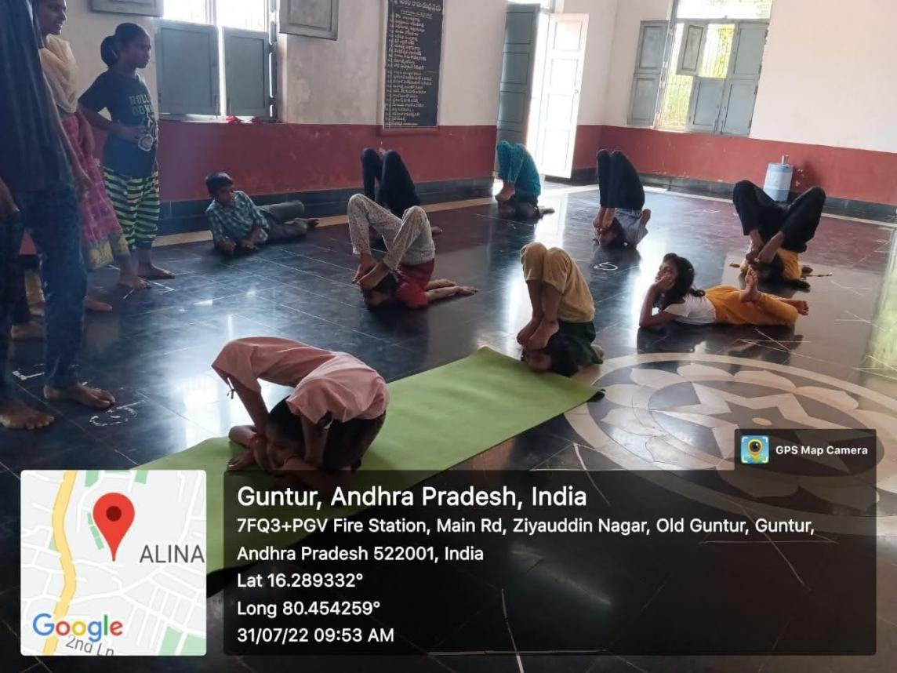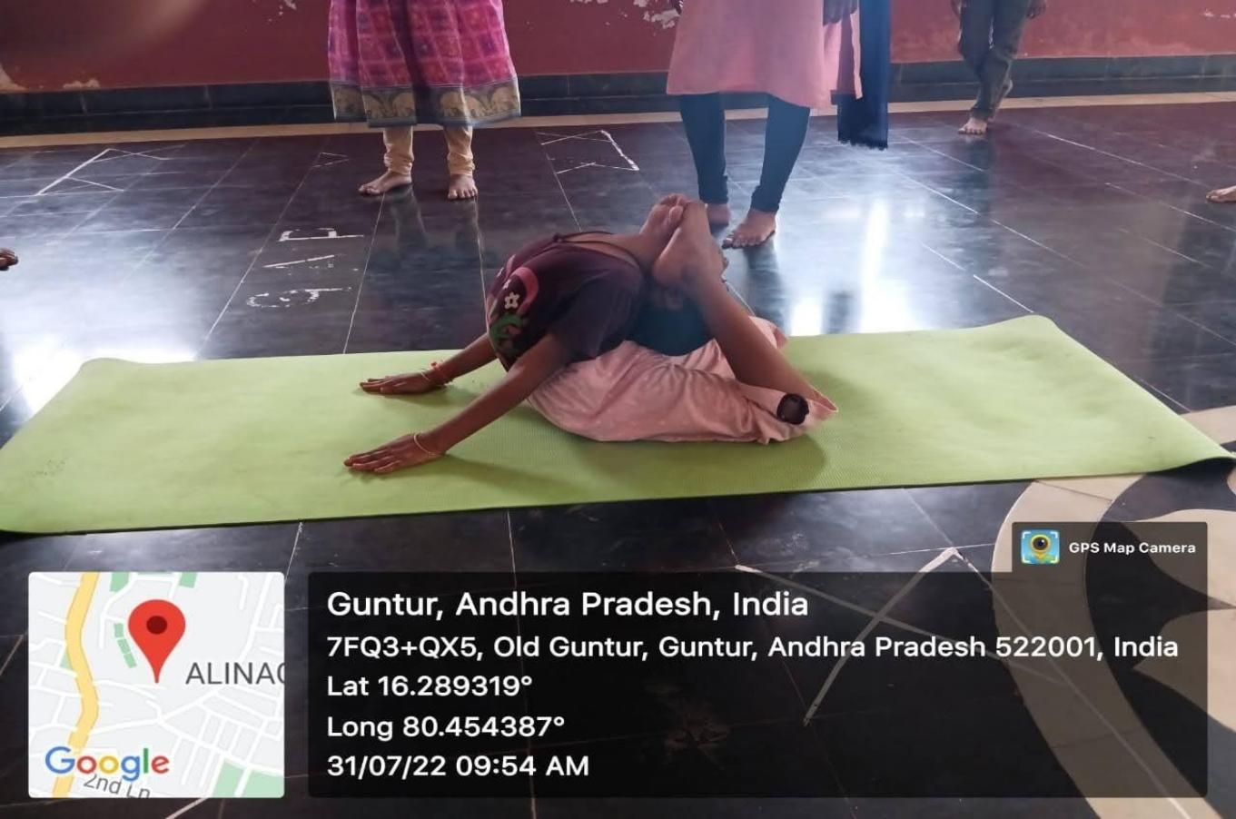

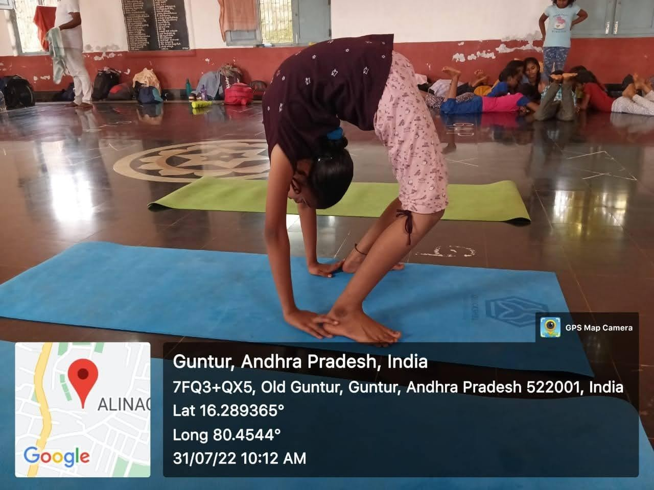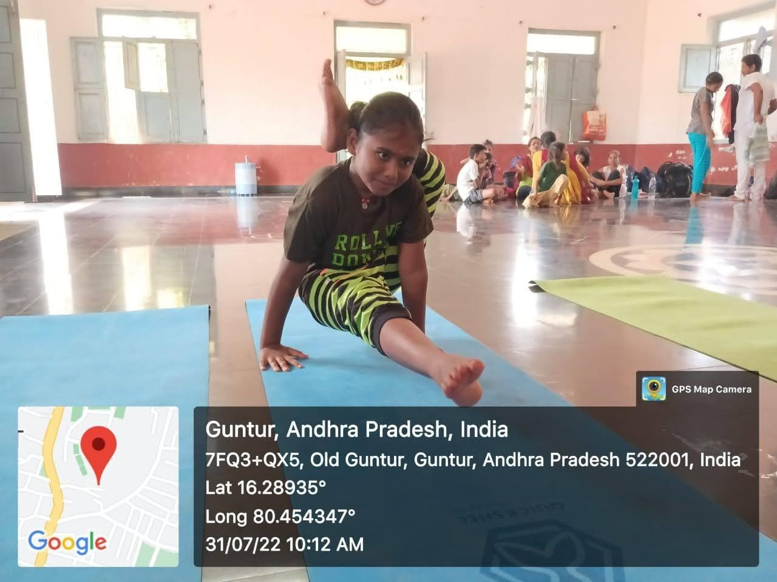

# EVALUATION

## MARKS STATEMENT

**(To be used by the Examiners)**

1. **INTERNAL ASSIGNMENT STATEMENT**

**INTERNALASSIGNMENT STATEMENT**

**NAME OF THE STUDENT :**

**PROGRAMME OF STUDY :**

**YEAR OF STUDY :**

**GROUP :**

**REGISTER NO :**

**HALL TICKET NO :**

**NAME OF THE COLLEGE :**

**UNIVERSITY :**

|  |  |  |  |
| --- | --- | --- | --- |
| **SI.N O** | **EVALUATION CRITERIA** | **MAXIMU MMARKS** | **MARKS AWARDE D** |
| **1.** | ACTIVITY LOG | **20** |  |
| **2.** | COMMUNITY SERVICE PROJECTIMPLEMENTATION | **30** |  |
| **3.** | MINI PROJECT WORK | **25** |  |
| **4.** | ORAL PRESENTATION | **25** |  |
| GRAN D TOTA L |  | 100 |  |

DATE: **SIGNATURE OF THE FACULTY GUIDE CERTIFIED BY**

**SIGNATURE OF THE HEAD OF THE DEPARTMENT/PRINCIPAL**

**SEAL:**

**INTERNALASSIGNMENT STATEMENT**

**NAME OF THE STUDENT :**

**PROGRAMME OF STUDY :**

**YEAR OF STUDY :**

**GROUP :**

**REGISTER NO :**

**HALL TICKET NO :**

**NAME OF THE COLLEGE :**

**UNIVERSITY :**

|  |  |  |  |
| --- | --- | --- | --- |
| **SI.N O** | **EVALUATION CRITERIA** | **MAXIMU MMARKS** | **MARKS AWARDE D** |
| **1.** | ACTIVITY LOG | **20** |  |
| **2.** | COMMUNITY SERVICE PROJECTIMPLEMENTATION | **30** |  |
| **3.** | MINI PROJECT WORK | **25** |  |
| **4.** | ORAL PRESENTATION | **25** |  |
| GRAN D TOTA L |  | 100 |  |

DATE: **SIGNATURE OF THE FACULTY GUIDE CERTIFIED BY**

**SIGNATURE OF THE HEAD OF THE DEPARTMENT/PRINCIPAL**

**SEAL:**

**INTERNALASSIGNMENT STATEMENT**

**NAME OF THE STUDENT :**

**PROGRAMME OF STUDY :**

**YEAR OF STUDY :**

**GROUP :**

**REGISTER NO :**

**HALL TICKET NO :**

**NAME OF THE COLLEGE :**

**UNIVERSITY :**

|  |  |  |  |
| --- | --- | --- | --- |
| **SI.N O** | **EVALUATION CRITERIA** | **MAXIMU MMARKS** | **MARKS AWARDE D** |
| **1.** | ACTIVITY LOG | **20** |  |
| **2.** | COMMUNITY SERVICE PROJECTIMPLEMENTATION | **30** |  |
| **3.** | MINI PROJECT WORK | **25** |  |
| **4.** | ORAL PRESENTATION | **25** |  |
| GRAN D TOTA L |  | 100 |  |

DATE: **SIGNATURE OF THE FACULTY GUIDE CERTIFIED BY**

**SIGNATURE OF THE HEAD OF THE DEPARTMENT/PRINCIPAL**

**SEAL:**

**INTERNALASSIGNMENT STATEMENT**

**NAME OF THE STUDENT :**

**PROGRAMME OF STUDY :**

**YEAR OF STUDY :**

**GROUP :**

**REGISTER NO :**

**HALL TICKET NO :**

**NAME OF THE COLLEGE :**

**UNIVERSITY :**

|  |  |  |  |
| --- | --- | --- | --- |
| **SI.N O** | **EVALUATION CRITERIA** | **MAXIMU MMARKS** | **MARKS AWARDE D** |
| **1.** | ACTIVITY LOG | **20** |  |
| **2.** | COMMUNITY SERVICE PROJECTIMPLEMENTATION | **30** |  |
| **3.** | MINI PROJECT WORK | **25** |  |
| **4.** | ORAL PRESENTATION | **25** |  |
| GRAN D TOTA L |  | 100 |  |

DATE: **SIGNATURE OF THE FACULTY GUIDE CERTIFIED BY**

**SIGNATURE OF THE HEAD OF THE DEPARTMENT/PRINCIPAL**

**SEAL:**

**INTERNALASSIGNSMENT STATEMENT**

**NAME OF THE STUDENT :**

**PROGRAMME OF STUDY :**

**YEAR OF STUDY :**

**GROUP :**

**REGISTER NO :**

**HALL TICKET NO :**

**NAME OF THE COLLEGE :**

**UNIVERSITY :**

|  |  |  |  |
| --- | --- | --- | --- |
| **SI.N O** | **EVALUATION CRITERIA** | **MAXIMU MMARKS** | **MARKS AWARDE D** |
| **1.** | ACTIVITY LOG | **20** |  |
| **2.** | COMMUNITY SERVICE PROJECTIMPLEMENTATION | **30** |  |
| **3.** | MINI PROJECT WORK | **25** |  |
| **4.** | ORAL PRESENTATION | **25** |  |
| GRAN D TOTA L |  | 100 |  |

DATE: **SIGNATURE OF THE FACULTY GUIDE CERTIFIED BY**

**SIGNATURE OF THE HEAD OF THE DEPARTMENT/PRINCIPAL**

**SEAL:**

**INTERNALASSIGNSMENT STATEMENT**

**NAME OF THE STUDENT :**

**PROGRAMME OF STUDY :**

**YEAR OF STUDY :**

**GROUP :**

**REGISTER NO :**

**HALL TICKET NO :**

**NAME OF THE COLLEGE :**

**UNIVERSITY :**

|  |  |  |  |
| --- | --- | --- | --- |
| **SI.N O** | **EVALUATION CRITERIA** | **MAXIMU MMARKS** | **MARKS AWARDE D** |
| **1.** | ACTIVITY LOG | **20** |  |
| **2.** | COMMUNITY SERVICE PROJECTIMPLEMENTATION | **30** |  |
| **3.** | MINI PROJECT WORK | **25** |  |
| **4.** | ORAL PRESENTATION | **25** |  |
| GRAN D TOTA L |  | 100 |  |

DATE: **SIGNATURE OF THE FACULTY GUIDE CERTIFIED BY**

**SIGNATURE OF THE HEAD OF THE DEPARTMENT/PRINCIPAL**